..9p i
Contents
Introduction 1
Main points of the application 2
Overview – the introduction of pace+ 3
What is PACE+ and what do I, as a user, need to know? 3
Components 4
How This Application Works 4
Steps to logging in 5
How to change the password 5
Logging off 6
The homepage of the FOUR DIRECTION 6
Menu 7
Feature Management 8
License feature module 11
Activate the license key of enterprise 17
To re-generate the license key of standard or enterprise 17
PACE+ 20
Add New Patient 20
Pink Warning Notice 20
Signing Forms 21
About Forms, Grids, Notes, and Tabs 21
Referral form 22
Referral grid 22
Add intake/ Enrollments details 23
Enrollment grid 24
Demographic form/ demographic grid 25
Demographic grid 26
Add service plan/ service grid 26
Service plan grid 27
Progress notes Grid 28
Clinical Assessment / clinical Assessment Grid 29
Clinical Assessment grid 31
Upload Documents 31
Documents Grid 32
Insurance Tab 33
Notes 34
Relationships 34
All charts will appear on client profile 35
PACE+ Menu Tab 35
Activity list 36
Pace ID (Client ID) 36
Workflow Type 38
Group notes 39
To Add group notes 39
Group progress note 40
Quick query 41
New Query 42
Fields and condition 43
Saving a Query 44
LOAD QUERY 45
About DSAL Reports 46
DSAL Report 47
Client Activity Log 48
Setup signature 50
Upload signature 51
Signature Pad 53
Draw Signature 53
Uploading signatures in forms 55
Timezone 55
Dash Board 56
Billing 57
Billing codes 58
Adding New Billing Codes 59
Edit Billing Codes 60
Delete billing codes 61
Note config 62
License config 63
Claim adjust 64
Billing Flow 66
Payors 75
Add New Payor 76
To Edit Payor 77
Delete the Payor 77
Providers 78
Add New Provider 78
To Edit a Provider 79
License group 80
Add New License 81
To Edit the License 81
To Delete 81
Rates 82
Add New Rate 82
To Edit the Rate 83
Add New Per Diem 85
About Admin Menu 86
PACE+ Admin 89
Diagnosis Code 90
Image Admin 91
Lookup Values 94
File Out Going 97
Files Incoming 102

Introduction
This manual is intended to be used as part of the overall information and knowledge strategy. That is, there are supplemental materials and training that must be available to the users or the trainees. Each user should attend at least an introductory training course for their role. These User-Guides created for FOUR DIRECTION PACE+ application training or the training can be given by another experienced user. Also, the user should have access to the test or training site so that the instructions can be followed and the user interface can be seen (the document contains the screenshots so that the user can easily understand the application).
Please note that for security reasons, not all users will have access to the functionality identified below. The following information is reflecting what is on the FOUR DIRECTION PACE+ test site. This will be updated to reflect production URLs later.
URL: https://4d.pace-plus.com/fourddevgui/Login.aspx

Main points of the application
This manual will give the user the background information about the PACE+ System and how to get started using it. It will illustrate and discuss
- The Overview of the application system
- What is Pace+
- Components of PACE+
- Login information for users
- Steps to login in and logging off
- How to change the password?
- Homepage
- Menu
- Pace+
- Dashboard
- Billing
- Admin

Overview – the introduction of pace+
A Hospital information system (HMS) is an element of health informatics that focuses mainly on the administration needs of hospitals. In many implementations, HMS is a comprehensive, integrated information system designed to manage all the aspects of a hospital's operation, such as medical, administrative, financial, and legal issues and the corresponding processing of services. One of the most important Problems is health care services. Hospitals provide medical assistance to people.
Welcome to the Four Direction PACE+ application of Interaction Information Technology. This User Guide gives you step-by-step procedures/definitions on how to use and operate this application.

What is PACE+ and what do I, as a user, need to know?
PACE+ stand for “Provider Automated Client Empowerment”. Let’s start with some background information about this system that you are using. PACE+ is an integrated web-based system for capturing, sharing, tracking and managing specific client information and services.
Electronic health records (EHR) are fully integrated with practice management (billing), reports, imaging and interactive forms. Because PACE+ operates over the Internet with role-based, tiered security, access to the system can be safely provided to whomever the organization desires. Access to the PACE+ system is available wherever the Internet is connected; in other words, virtually everywhere. This is a plus for staff members working outside the office or outside of regular office hours. Controlled by login and password security, users can record notes or complete an assessment wherever they happen to be, instead of waiting to return to the office. Electronic health records are carefully stored in a single electronic file of each client’s clinical and demographic data from initial contact through the completion of treatment.

Components
Components include scheduling, referral, add intake/enrolment details, demographic, clinical assessment, service plan, progress notes; and all are fully integrated with reporting and scanning capabilities.
PACE+ incorporates an audit management tool for each form in the electronic file, tracking any changes in the electronic health record. Each creating, or editing progress notes prior to submission, is date and time stamped. Supervisors can monitor activity logs and reports and use version control to view or print authors and times of use. This tool also allows claim tracking individually or by date to accurately address billing denials.

How This Application Works
- Login information for users
- Steps to login in and logging off
- How to change the password?
- Homepage
- Menu
- Pace+

Login Information for the user
Go to Google and click on the link “link”. PACE+ is a right based security system. User visibility and accessibility are different based on their individual logins and rights assignments.

Steps to logging in
- To log-in enter your assigned User Name and Password.
- Click on the login to your Account
- Upon success, the login will disappear. You are now logged in to PACE+ and the home page appears with the available menus and functions based on your individual access rights.
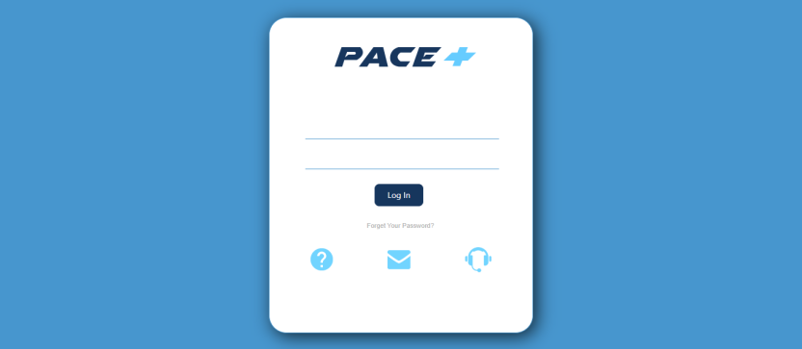

How to change the password
At the top extreme right-hand side of the page, there are two portions “User Profile, Help” or “log out”. If you want to Change Password, Click on User Profile. To change your password user must have logged in prior. The screen appears as shown below. On the Change Password section, Enter Password, Then your new Password and then confirm your password. In this way, you successfully change your password.
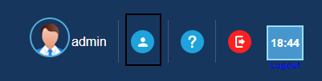
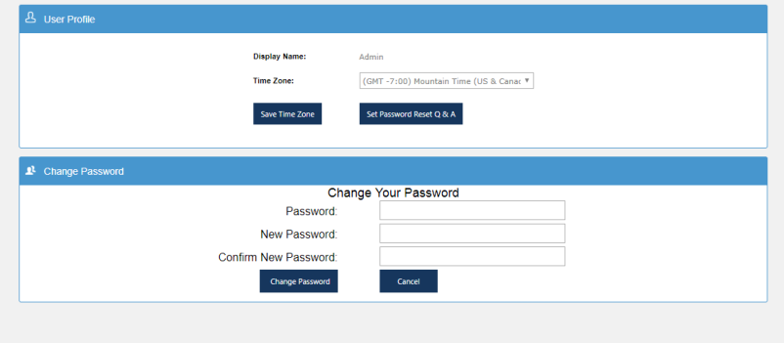

Logging off
At the top extreme right-hand side of the header menu, there are two portions “Profile, Help or “log out”. The preferable log off procedure is to click on the log out. The screen will be returned to the home page where the user logged in prior. If you do not see the tab of log out on the right side of the tab, there is a possibility that your session has expired.
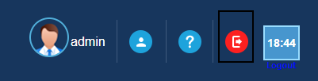

The homepage of the FOUR DIRECTION
When you successfully log in. You will come to this page. On the top of the page, a timer is given. We can say it a “Session timeout”. The application times out after 20 minutes (default) of no activity to the web page (need to log in again if needed). In the top right-hand corner (banner) displays a timer to give the user the amount of time left before the warning pop-up appears (if an action activity is sent to the page/server, the timer resets back to 20 minutes).
The warning display has a countdown timer of 1 minute; the user needs to click on the ‘OK’ button to keep the session active (not logging off the user). If the ‘OK’ button is not clicked within the timer countdown, the session will expire and any data entered in a web form (e.g. demographic filled forms etc.) will be lost if not saved prior. If you click the ‘Cancel’ button, it will log you off the application. Please note, if you are in a separate window (not the main web page) the timer continues to countdown.
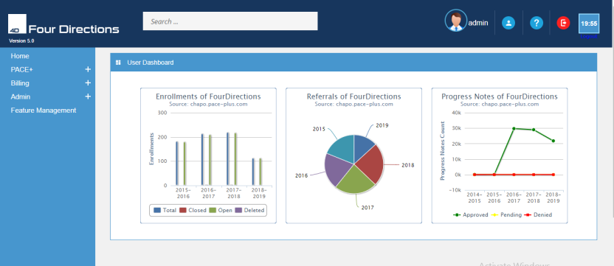

Menu
Access to menus depends on user rights. Each menu items have its own sections of users guide for a detailed explanation of that function or items. When you are hovering your pointer over the menus may expand additional menus. Hovering over the icon will also display the type. Main menus are the following:
- Home
- PACE+
- Billing
- Admin
- Feature Management
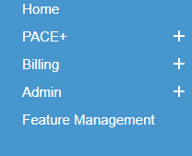

Feature Management
Go to the menu Admin tab. Select the “Feature Management” from the drop-down submenus. Click on the feature management – takes you on this page. You can see the 3 categories:
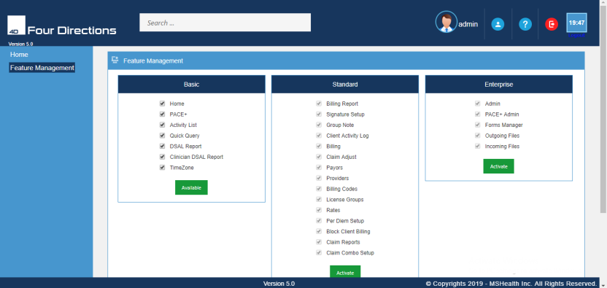
- Basic- Basic features provided to every customer. Client needs to select each feature and then click on available as shown below.
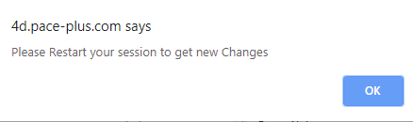

The client gets this pop-up on the top of the screen. Click on ‘OK’.In this way, the Client Is able to access the basic features. Now click on restart the application and use basic features.

- Standard- Standard features are paid.
- Enterprise- Enterprise features are paid.
If the Client wants to use standard and enterprise features then the client sends a request for standard and enterprise features.
Send an order then the client pay the amount for the license. You will get that notification pop-up on your screen.
The key will be sent to the client. Enter that key.

After entering that key below mentioned pop-up appears. The user after buying these features able to active or inactive the features.

License feature module
Go to the menu Admin tab. Select the “Feature Management” from the drop-down submenus.
Click on the feature management – takes you on this page. You can see the 3 categories:
- Basic- Basic features provided to every customer
- Standard- Standard features are paid.
- Enterprise- Enterprise features are paid.
If the Client wants to use standard and enterprise features then:
- The client sends a request for standard and enterprise features.
- Activate the key for standard and enterprise.
You can see the Basic level is already available for the users whereas, the standard and Enterprise will be showing the option to get the license.
After that, you can excess further features and select your desired options by clicking on checkboxes.
How to send the order and get the license in standard version
Click on the orders to send the order. You have to provide your email address. You can see from the image down below how it works.

It might take a few seconds to process.
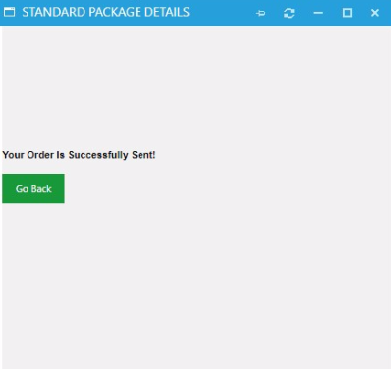

It will show a message on your screen that your order has been sent.

You can copy this license key and paste it on the verification track to activate it.

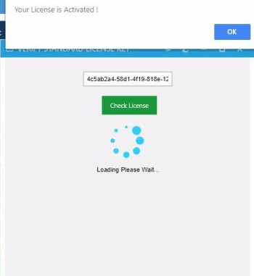

It will show a successful message on the screen. Now, your standard version is activated.
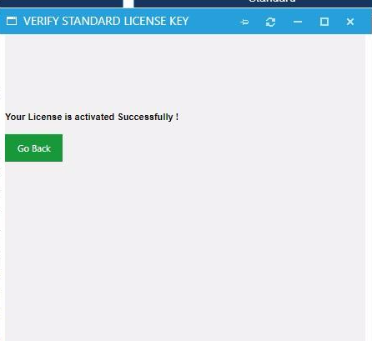

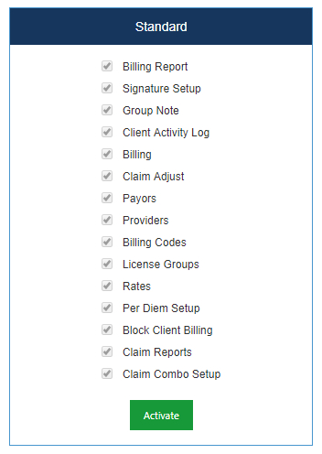

Activate the license key of enterprise
The producer is the same for both the standard and enterprise.

PACE+
When you successfully log in this application. On the home page, go to the PACE+ tab and click on it. A new form will appear that is based on “PACE ID, Referral Date, Last Name, First Name, SSN, Date of Birth, CIS ID, and AHCCS ID”. Here you can search for your patients. Write their name, Pace ID and click on search. You can also add more while clicking on Add Individual.

Add New Patient
When you click on the pace+, you will come to this page. Here you will initiate the “Client Search” or to “Add Individual”. A form will appear where you can add new patient details.
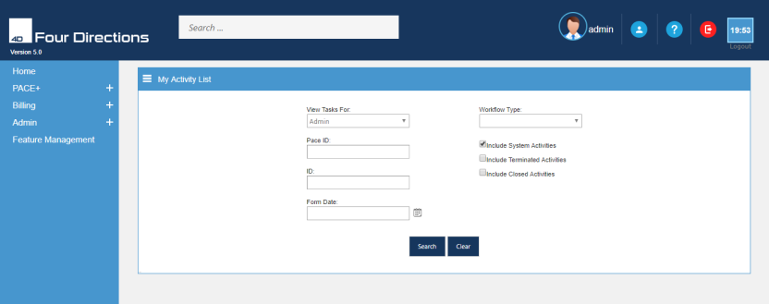

Pink Warning Notice
If this pink warning area displays in a field in any of the web forms (i.e. referral, intake, etc.), one of two requirements are given for that field:
- It is a required field and must have a value
- Invalid entry (i.e. incorrect format, incorrect value)
Hovering over the pink area to display the message of warning. This must be corrected before saving the form.

Signing Forms
In most of the forms, there is a block of “Signature”. Here you can add (Signature, Password, No Signature, Signature pad and signature needed). Without solving this, your form will not be saved. If you select the No signature, then it requires simply to be saved. But if you select from one of the drop-down options like “Signature Pad”, then you should sign your signature on the signature pad. It will show on the form when it is completed and is electronically attached to that form. When you hit on the save button and the form is saved. You can also create an image of your signature and insert into the document on the signature line.

About Forms, Grids, Notes, and Tabs
- Referral form/ referral grid
- Add intake/ enrollment
- Demographic
- Service plan
- Progress notes
- Clinical assessments
- Documents

Referral form
Add new Patient Details User can enter the data in this form than further process continues. Fill data and hit on the “save” button. A referral form will be saved.
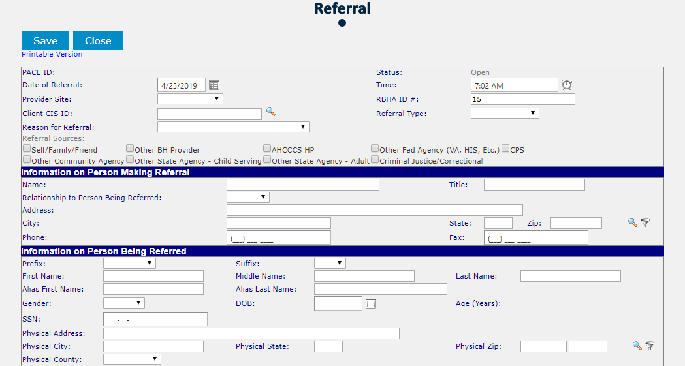

Referral grid
The referral form record is saved in Referral grid. In this grid these features are displayed, view, Print ,View Referral History ,Add Intake ,Schedule Intake and Delete . it consists of the following terms:
- Pace ID
- Referral ID
- Referral Date
- Status
In view icon Referral form also has the “Edit” option. Pace+ system automatically generated “Referral ID” against the Referral record. This is basically the referral record list. We can see in this figure.
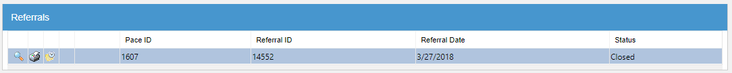

Add intake/ Enrollments details
Add intake after entering the patient information on the referral form. When you click on this icon (add intake). You will come in this form. Here you can enter the information that is required.
The referral form saved in the referral grid as like the Enrollment form is saved in Enrollment grid. In enrollment grid, we are discussing the features which are displayed like, view, Print, View Intake History, Delete/. In view icon, there is an option of “Edit” Enrollment form. Pace+ system automatically generated “Enrollment ID”. In these fields (Enrollment ID, Referral ID, Intake ID, ROI, Closure Date, Type, and Stage) details enrollment record is maintained.
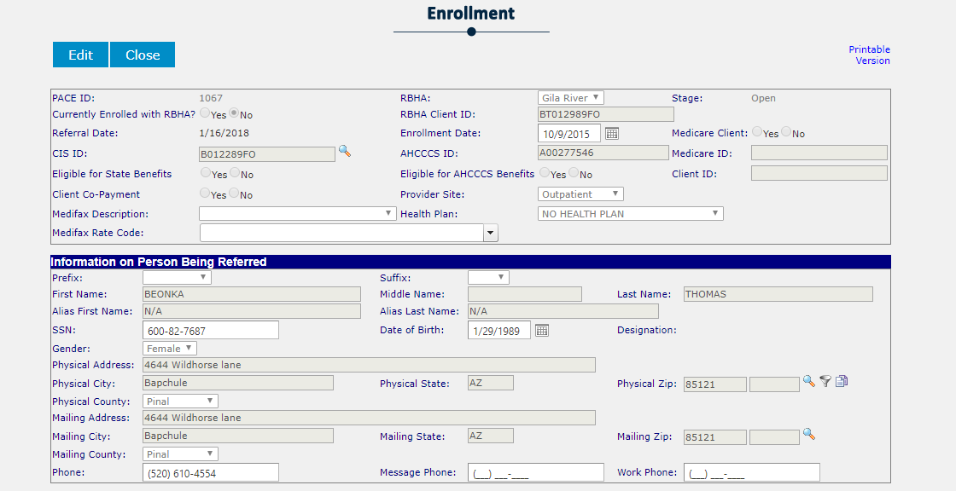

Enrollment grid
Here is the enrollment grid. This will give you more options to add more details like that. Add demographic icon. Add Services Plan icon ,Add Progress Note icon Add Psych Evaluation icon Add Psych Progress Notes icon Add medical demographics icon Add Crisis Plan icon Add CFT Note icon Add Strength needs Cultural Diversity icon Add PCP communication icon Upload their documents icon Add Clinical Assessments icon Add Tracking Referral Log icon Add Client Health Summary icon Add Wellness Recovery Plan icon

Demographic form/ demographic grid
After adding the intake and enrollment form we come to demographic form. As with other forms, demographics will be saved in the demographic grid. In view icon, Demographics form is open and the user can enter the data. That form consists of:
- Basic Client Information
- Guardian Information
- Limited Income Subsidy (LIS), Employment Status
- Educational Status
- Child Outcome Measures
- Special Population Identifiers
- Substance Use
- Mental Health Diagnosis
- Primary Diagnosis
- Physical Health Diagnosis
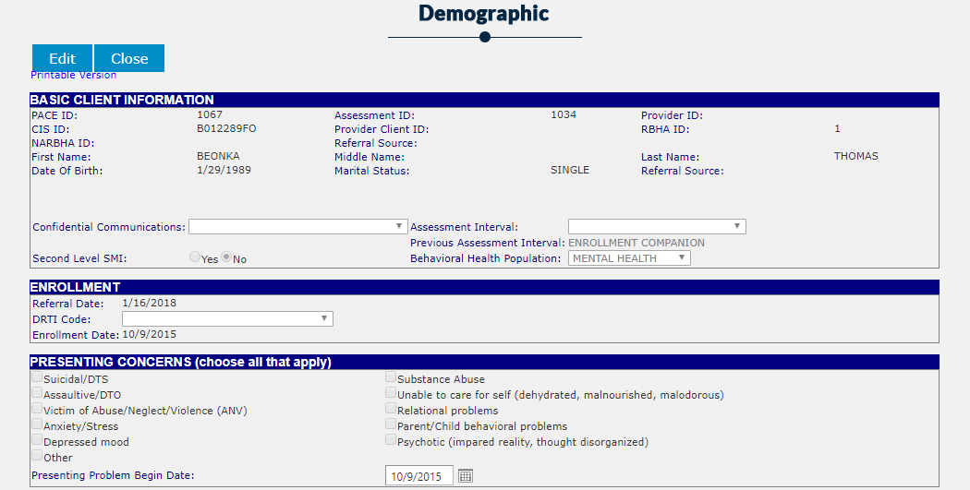

Demographic grid
Demographics grid consists of these fields ID, Intake ID, Date of Assessment, Behavioral Health Category, and Stage.
In this grid, these features are display, view Assessment, Print Assessment, View Assessment History , and Delete .
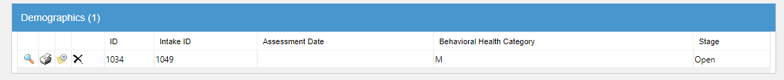

Add service plan/ service grid
Go back to the enrollment grid and click on the “Add service plan”. A form will appear. That form consists of the followings:
- Patient pace id
- Last and First name
- Recovery Goal/ Person/ Family/ Vision
- Peron’s Strength
- Service Code Authorizations
- Discharge Plan and Signature section
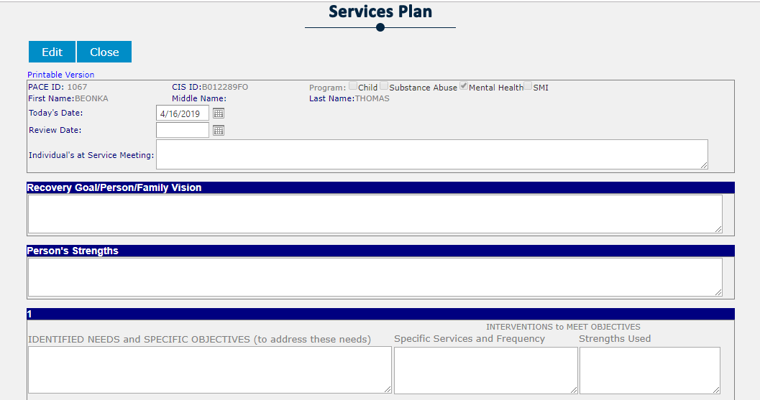

Service plan grid
Service plan grid consists of Service Plan ID, Intake ID, and Signed. The Service Plan form is saved in the Service Plan grid as like other forms.
In this grid, these features are display, view Assessment, Print Assessment, View Assessment History , Delete. In view icon Service Plan form is open and the user can enter/Edit the Service Plan.
Progress note / progress grid
After adding the service plan grid. Go back to the enrollment grid and select the “progress note”. A form will occur which consist of the followings:
- Patient pace id
- Client name
- Date of birth and Status
- Date of service (DOS)
- Billing Codes
- Allergies, Medications, Assessment.
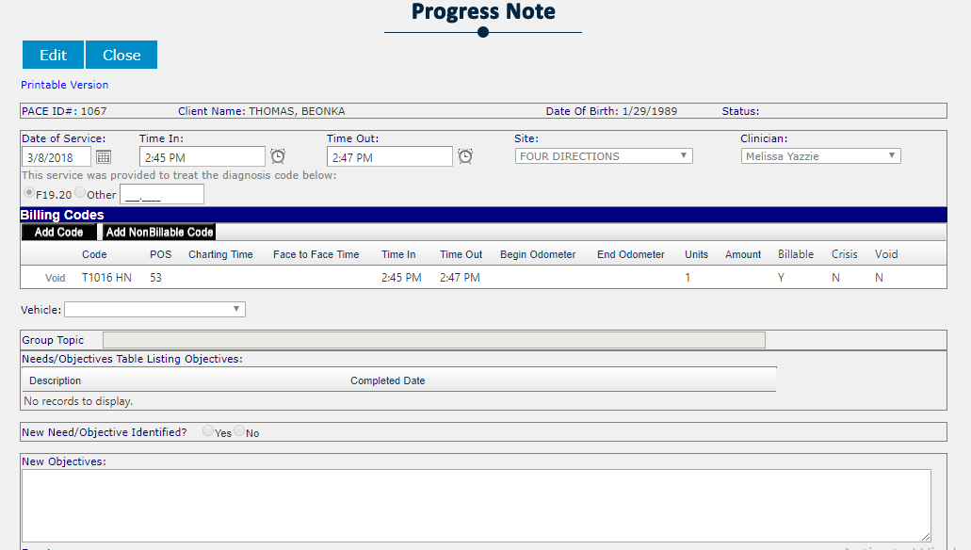

Progress notes Grid
The Progress Note form is saved in the Progress Notes grid. Progress Notes grid consists of these fields Daily Progress Note ID, Enrollment ID, Date of Service, Clinicians, and Signed.
After saving the form when you go back to the page, here is the icon of view in the progress note grid when you click on it you will come to the progress note form and the user can enter/Edit the Progress Note. In this grid these features are displayed, view/edit Daily Progress Note, Print Daily Progress Note , View Daily Progress Note History and, Delete. Filter option is also given in the grid.
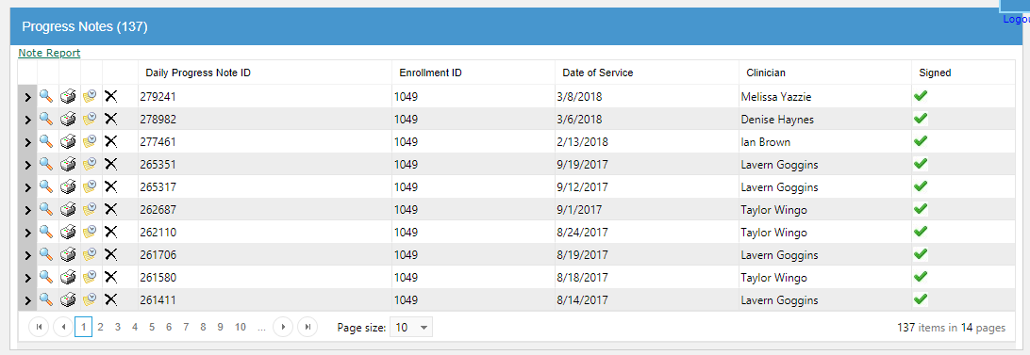

Clinical Assessment / clinical Assessment Grid
Go to the Enrollment grid and select the “Clinical Assessments icon”. Assessment Section is opened. Select any one option and click on the “Open button”. The selected form is open. Enter the data in open form and hit on save button. So, the data is displayed in the Clinical Assessment Grid. Clinical Assessment grid consists of an ID, Enrollment ID, Part and Signed.
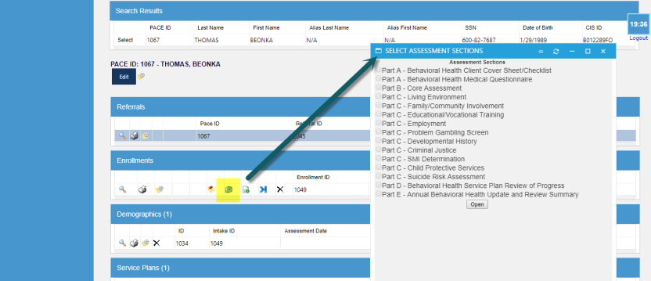
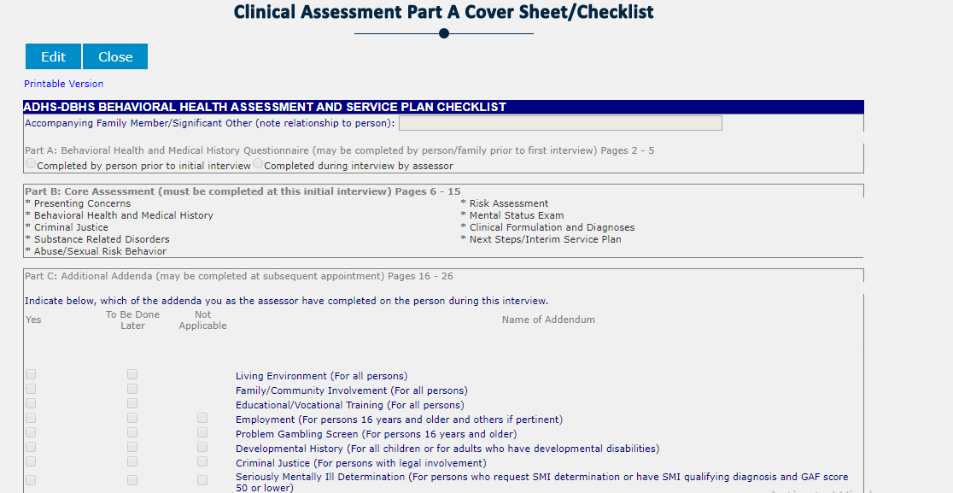

Clinical Assessment grid
It consists of an ID, Enrollment ID, Part and Signed. Clinical Assessments Part A, B, C, D etc. is saved in Clinical Assessment grid as like other grids. In this grid, these features are displayed as like, view Note, Print Note, View History and, Delete.
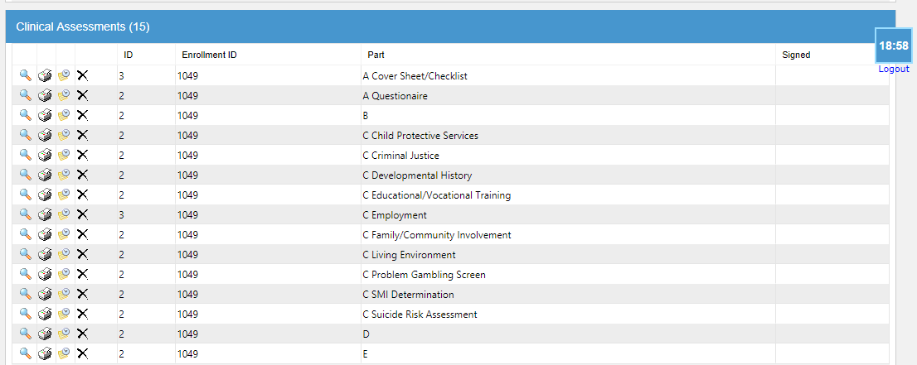

Upload Documents
After completing the form PCP Communication, go back to the enrollment grid and click on the “Upload Documents”. Upload document section will appear when you click on the “select” then upload the document here. Enter the data in open form and hit on “Accept button”. So, the data is displayed in the “Document grid”. By using this feature user can easily upload the document. In this grid “forms” drop-down option is given.
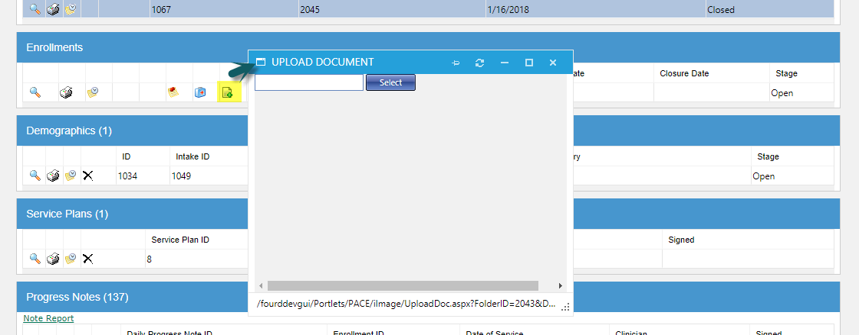
That form consists of these fields, subfolders, name, and doctype, Info (Intake ID, Title, File type, and file size, created by).
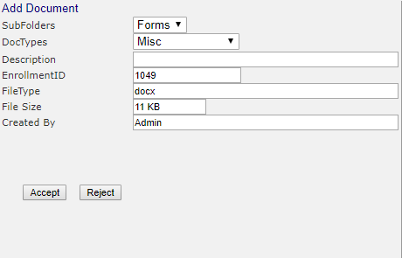

Documents Grid
This document is saved in this Grid. Uploaded document is also viewable by using this icon and Edit by using this icon. Filters option is also given. In this grid “forms drop down” option is given. When you click on the “open”. A drop-down form will appear in which you select the forms according to your requirement.
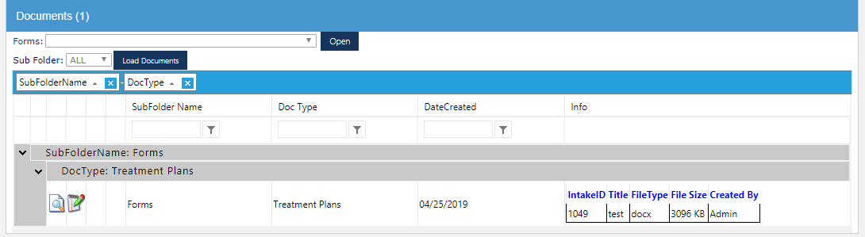
TABS
After the document grid, there is a tab grid which consists of different tabs. These tabs are following
- Insurance
- Workflow Tasks
- Notes
- Relationships
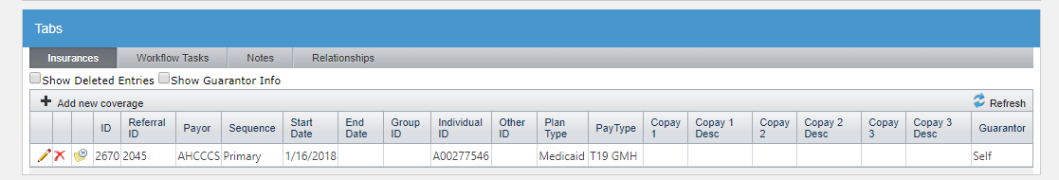

Insurance Tab
Go to the insurance tab click on it. A tab will appear then click on “Add new coverage”. After that, a form will come in front of you. Here you can enter the information and then click on the “insert”. Your insurance form will create successfully.
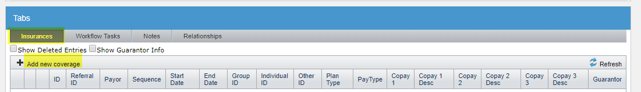

Notes
Go to the Notes tab and click on it. A tab will come, fill the requirements and hit on the “save” button. Here you can add the drop-down category. Notes form will have created in that way.
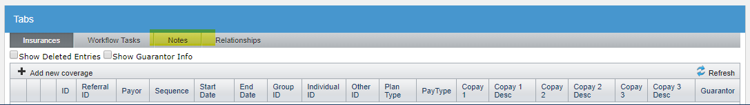

Relationships
Go to the Relationships tab, click on it and then click on the “Add Relationship”. When you click on it a form will come that is based on “PACE ID, first name, Middle name, Last name, Gender, DOB, Monthly Income, Race, Suffix, SSN, and Relationship”. After entering the data hit the “Save” button. Your relationship will be created successfully.
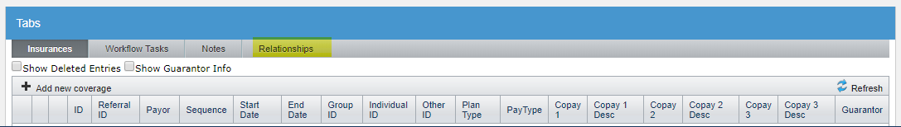

All charts will appear on the client profile
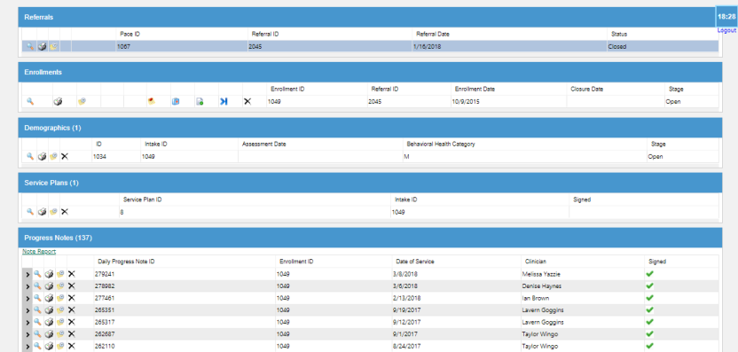

PACE+ Menu Tab
Hover over the pace+ menu tab so, you can see the drop-down list of reports. Drop down list are the following:
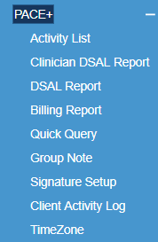
Firstly, we are discussing some specific reports that are created for immediate use. These reports are “Activity List, DSAL Reports, DSAL Clinician Report”. PACE + is basically a collection of already created reports, depending on permissions and role. Some are clinical reports while others will assist in the billing section. Click on the Activity List to open the iWork flow program in PACE+.
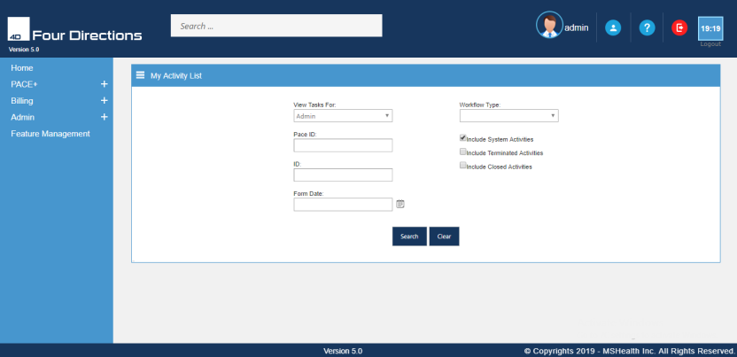

Activity list
We can say that there is one report which is based on iWork flow program and that report is known as “Activity List”. This report can assist staff in searching for tasks assigned to them. Staff may search for completed activities and for things like “Enrollment”, “location” or status as “open” to get a count for how many activities a user has open.

Pace ID (Client ID)
Another way to search the Activity Log is by PACE+ ID (Client’s ID). If I wanted to know how many notes were ever written for Pace ID #38112. I would enter the PACE+ ID that is located just below the View Tasks for, after entering the PACE+ ID, hit on the “Search” at the bottom left side of the page.
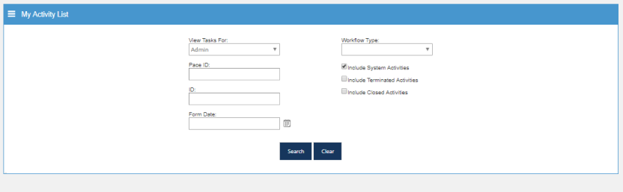
If you wanted to see what notes were written for a Client on a date, you need to enter the “PACE ID” and the “From Date”. You can also select the “Workflow Type” for better understanding. Here you can check your notes separately like, PACEWF. Private Intake, PACEWF. Referral, PACEWF. Note Reminder” etc. You can also submit their forms here.
After selecting the pace ID and workflow, results will appear. Here you can select your location output like “Waiting for Enrollment Response, Enrolled, and Submitting Re-enrollment”. When you select your location output then click on “submit”.
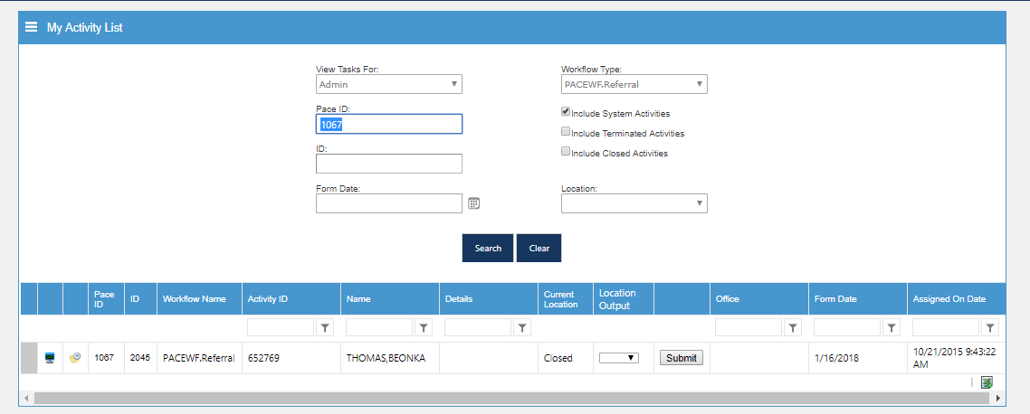

Workflow Type
Pull down empty the all these terms like “View Tasks for, Pace ID and Form date”. You can only select “Workflow Type”. A list appears which consist of different “PACE ID, ID, Workflow Name, an Activity ID, Name, Details, Current Location (whether it is open or closed), Form Date, and Assigned on Date”.
Therefore, users need to enter as specific details as possible so that they can get useful information out of the system. This report has 29 pages. We check the open lists as well as closed lists while selecting the location.

Group notes
To add a group note, go to the PACE+ button on the Home page. Group notes are available in PACE+. However, adding a Group Note is a bit different than other notes that have their own icons. It does not have an icon. Hover and open the submenus. Click on the “Group Notes” submenu. This will open the Group Note screen, where you can locate an existing note or add a new group notes which are located on the bottom right side of the page.
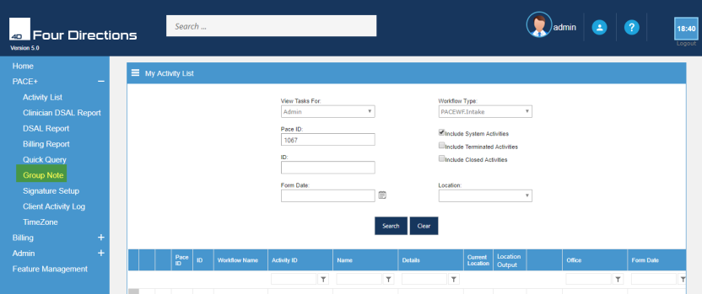

To Add group notes
When you click on the Group notes. A Group note screen will appear. We can also call them DSAL Reports. You can see on the top right side of the screen “DSAL report”. Its depend on “Group ID, Date of Service, Clinician”. When you click on the clinician bar a drop-down form will appear. Here you can add a new group form that is “Group Progress Note”. You can also search for the existing data and clear them.
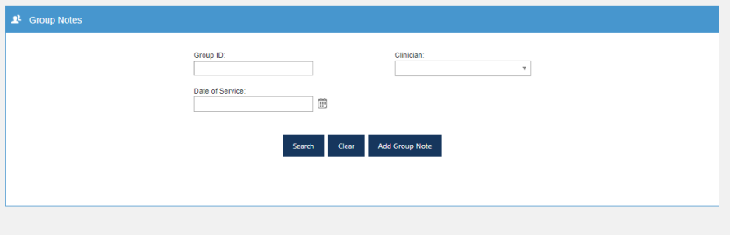

Group progress note
When you click on the “Add group notes”. This form will appear. This form consists of Pace ID, add client and common files like the site, location, Assigned Clinician, Date of service, Appointment time, HCPC, Time in and Time Out”. To create a group note you will need to add the clients to the group. If you know their Pace ID, you can enter that number and click on the filter icon . This will fill client information into the note from the Pace ID. But in case you do not have a Pace ID, click on the search icon by adding the information like Date of birth, intake ID, social security. If more than one client is displayed from a name search, click on “Select” in front of the name of the person who is in the group that you are writing notes. When the correct client is located, click the “Add Client” command under the Pace ID at the left edge of the screen
When you click on the add client, it will add the client here. You can see it on the Clients list tab and Notes tab at the bottom of the page. You can also add more clients and the procedure will be the same. When you fill the form then click on the save button. Then go back to the Group notes. Here you can search the group progress notes while putting the “Group ID, select the clinician from the drop-down list and the Date of service”.

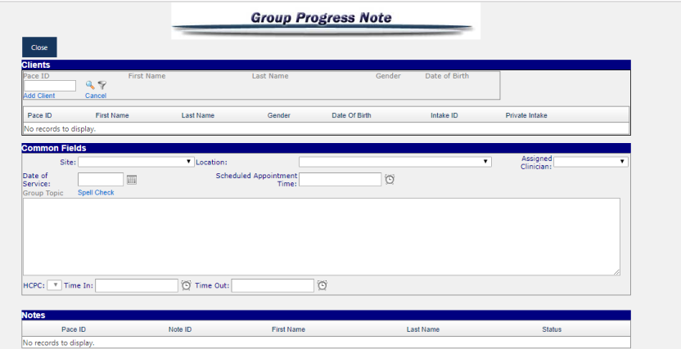

Quick query
When you hover on the PACE+, a menu list will appear. Click on the “Quick Query” name on the function list. This will open the “Quick Query” report generator. Quick Query can be customized for each user to mine the data information which they need. When you click on the Quick Query, this tab will open. Here you can see there are two options:
- NEW QUERY
- LOAD QUERY

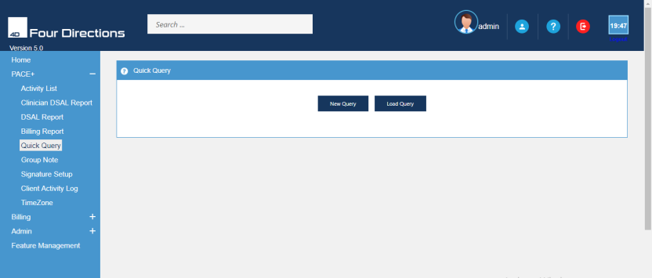

New Query
New Query is a Command bar that opens the report generator, allowing a query to be created. When you click on the “New Query” will display the items. Choose the field from which you wish to create the report. A sampling of reports that can be created via Quick Query Are Referral Status, Referral Type, Referral Reason, and Intake by date, Demographic information, Service Plans, various types of progress notes, Late Entry progress notes, Closure, etc. Presently there are different available fields. Each field has a “” icon in front indicating the subfields that you may choose. When you click on the “” icon, a subfield will open, where you can choose the field according to your requirements.
When you have selected the fields and subfields, then click on the “Add”. It is located at the upper right side of the page. Your new queries will be created successfully. You can minimize the fields tab by clicking on the negative sign icon that is “”. Your selected subfields will be saved. You can continue your process safely.
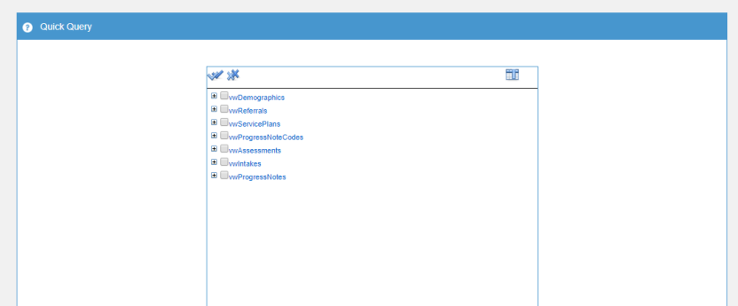

Fields and condition
Here you can see the “Fields” that you have selected will appear on the left side of the screen and reflect those selected fields. These selected fields will be the column on your report. On the right side of the page, there is a column of “CONDITIONS”. Select the condition from the matching field.
Here is the example “wwAHCCCSSegmentinfo” this is the field and “DOB” is its subfield that you have selected above. Go the tab “Click here to Add New Condition”. Click on this tab, a drop-down list come. Select one of condition that is required of you. This condition will be implemented in that field.
If you select and add a wrong field you may delete it by clicking on the blue arrow that is in front of every fields and condition. Click on it and select “delete the row”.
After putting the data, you can click on the “RUN QUERY” which is located at the bottom right side of the page. Click on it and your query will be created. The results of that query will be shown at the bottom of the page. The name of the result tab is “RESULT”. If you want to print or save this report, then click on the “Export to Excel” command button. This will create an Excel spreadsheet for you to print, save or modify as you need.
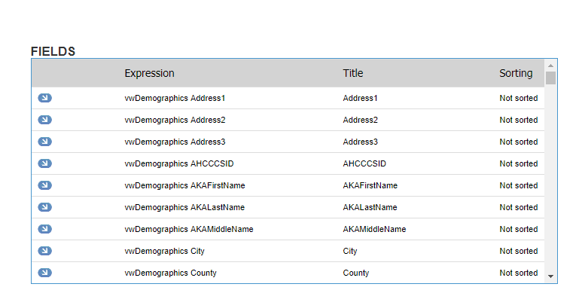

Saving a Query
Once you are sure that you have all the fields and conditions that you need, by running the query and viewing the results then use the “Save As” function to save the details of this report for future use. If you want to save the report and you may need to run again the same report, then click on “SAVE AS” button. So that you will not have to recreate it each time. This function will save you from having to re-enter all the fields and conditions again. This function also saves you time.
When you click on the “SAVE AS” button, a pop-up alert will show on your screen. Here you can see “USER, ROLE, QUERY NAME” is required. If you are Saving as “User” makes this query available to only the user but if you are saving to “Role” makes it available to anyone in that Role. “Query Name” is very important because it will make easier to find this query next time you need to run this report.

Load Query
Load query is a Command bar that opens the report generator, to a drop-down list of saved queries allowing the user to select an already created query. Such reports often require time to select all the variables and create the conditions, but once that is done, PACE+ will allow you to save them and quickly access them for future use.
When you click on the “Load Query”. Saved queries option will come with a drop-down list. Find the title of your saved query from the drop-down list. Therefore, it is very important that when you title your query, you take the time to make it identifiable. Select the saved query from the drop-down list. It is initiated because it was saved under “Role”, so the person who created it is noted in the title.

When you select the saved query like “Psych Notes missing HCPCS”. The results are shown below. All the previously selected criteria will open for “Fields” and “Conditions” and you may run and delete this report at any later date, without having to re-enter all the specifics again. Click on “Delete” button. A “Warning Pop-up” will ask if you are sure that you want to delete. “Ok” deletes the query and it no longer is available for selection.
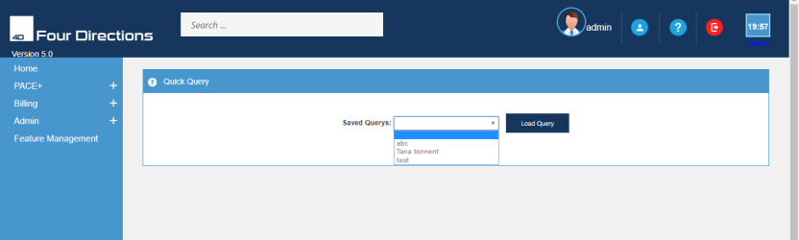
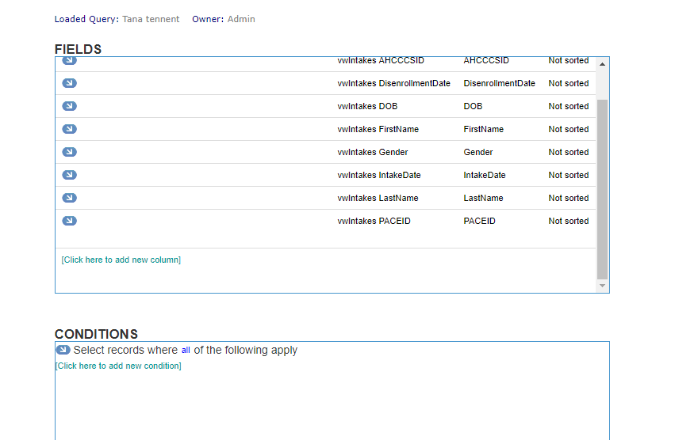

About DSAL Reports
DSAL stands for “Daily Staff Activity List”. Here we are discussing two reports in PACE +. These reports are “DSAL Reports and DSAL Clinician Reports.” DSAL Report is available to Administer and Center Manager. While another DSAL Clinician Report is available for both Manager and clinician staff (therapists). To access the DSAL Reports, go to the PACE + menu tab, select the Report from the drop-down list.

DSAL Report
Select “DSAL Report” from the drop-down list on the menu tab. This will take you to the DSAL data range page. This report is the like the DSAL Clinician report except for the dollar value of services is displayed for all the staff’s notes for the entered time. Anyone that has the rights to this report, can check the “Show Dollar Amounts” box. The results open in an Excel spreadsheet.
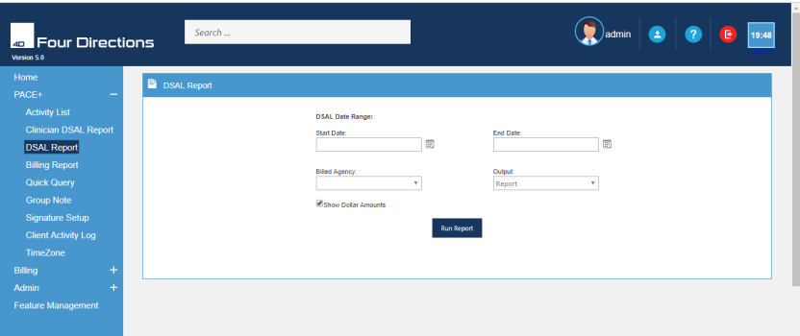
Enter a numerical date range Start Date and End Date. Enter the start date you want to start the report from. Enter end date you want the report to end. Enter the column “Billable” select on the drop-down list whether it is billable then enter the name of the “Bill Agency”.
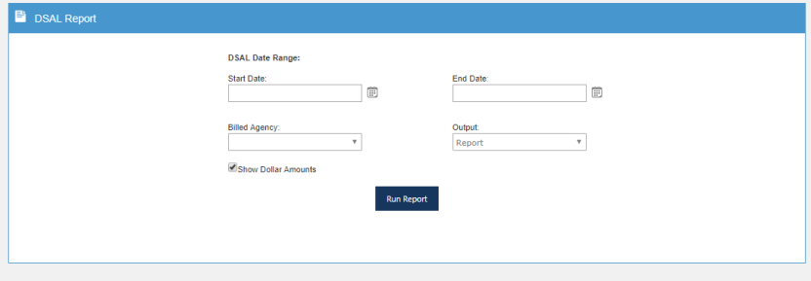
This report shows all the HCPC codes, Daily amounts of time and units, all the clients, progress note ID, billing codes, progress note types, HCPC codes, time in/time out, amount of billing time, amounts of time and Behavioral Health Category of services during your selected time interval. For example, you have selected the time from 2/1/2017 to 1/15/2017.
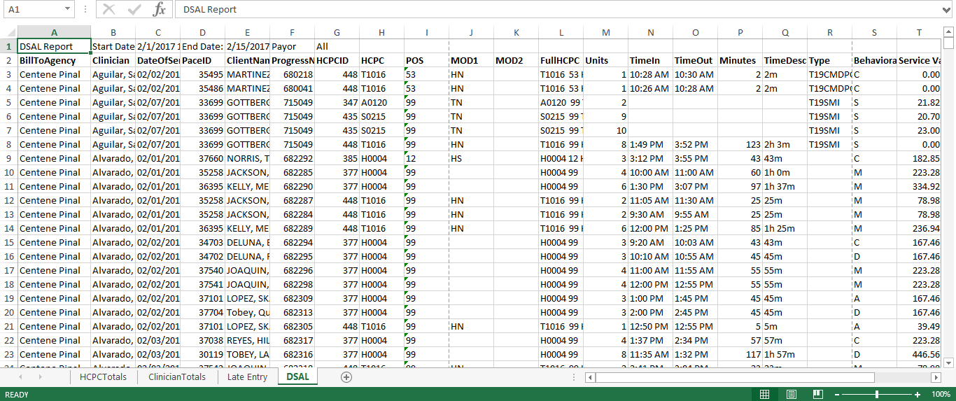

Client Activity Log
Select “Client Activity log” from the drop-down list on the menu tab. This will take you to the Client Activity data range page. This report is the like the DSAL Clinician report except for the dollar value of services is displayed for all the staff’s notes for the entered time. Anyone that has the rights to this report, can check the “Show Dollar Amounts” box. The results open in an Excel spreadsheet.
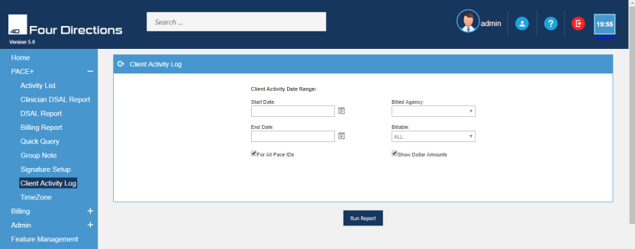
Enter a numerical date range Start Date and End Date. Enter the start date you want to start the report from. Enter end date you want the report to end. Enter the column “Billable” select on the drop-down list whether it is billable then enter the name of the “Bill Agency”. For all pace IDS and show Dollar Amounts.
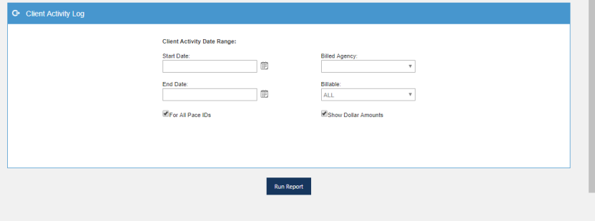
This report shows all the HCPC codes, Daily amounts of time and units, all the clients, progress note ID, billing codes, progress note types, HCPC codes, time in/time out, amount of billing time, amounts of time and Behavioral Health Category of services during your selected time interval. For example, you have selected the time from 1/29/2018 to 6/14/2018.
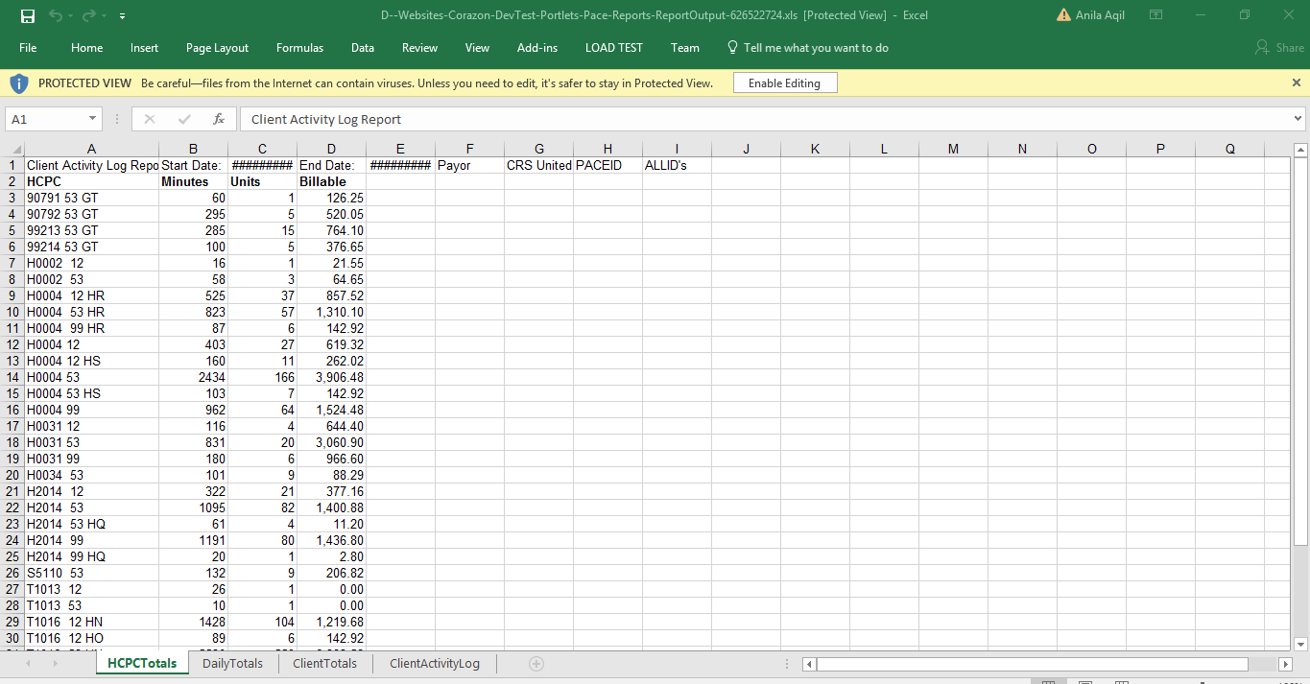

Setup signature
Hover over the pace+ menu tab so, you can see the drop-down list of reports. Click on the “Setup Signature” sub-menu of PACE+. This will take you on the setup signature page where you can add the password, signature pad, and signature. This will use in many forms.
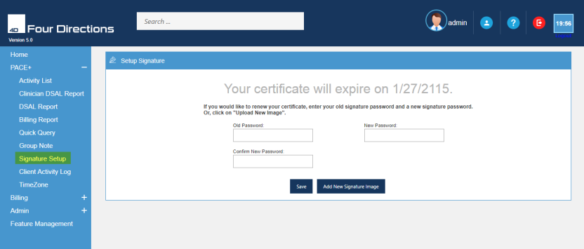

You can renew your password and/or add a new signature. Enter your “Old password” then create a “New password” and re-enter your new password on the “Confirm New Password” textbox. Hit the “save” button.
If you want to add a new signature. Click on the “Add New Signature image”. It is located at the extreme bottom left-hand side.
There are three types of signs that can be used by users. These signatures are
- Upload signature
- Signature Pad
- Draw signature

Upload signature
First-time users uploading their signature. Click on the “upload signature”. A form will come. Click on the ‘Select’ button to navigate to the location of the scanned file. For Example Desk Top, Pictures, My Documents.
Once you have located the file, select it and click “Open” to load it in the Upload Signature page of PACE+. Once you clicked Upload the preview of the signature will appear. If it does not, then you either have a format that is not accepted for the upload.
Note Image will be resized to 300 x 600 when displayed as a signature.

If the signature is acceptable, enter a “Password” (the password must be at least 8 characters in length and must contain either a number or a special character. For Example #, %. Confirm your password and click the “Save” button at the extreme bottom left-hand sided. Once the signature is saved and password protected, select “Password” to attach your signature to the form or document that you are signing.

Signature Pad
Click on the “Signature Pad”. A form will come, here you can sign and click on the Submit. You can click on “clear” in case if you are not satisfied with it.

Draw Signature
Click on the “Draw signature”. Here the users can draw the signature as they want to create it. After that, click on the “Submit” button. Your signature will be created successfully. You can use it whenever the signature is required at any forms like psycho forms, clinician forms etc.
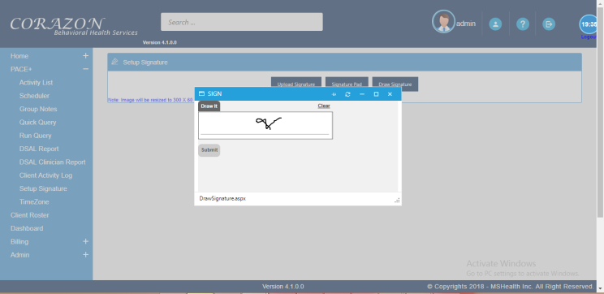
If the signature is acceptable, enter a “Password” the password must be at least 8 characters in length and must contain either a number or a special character. For Example #, %. Confirm your password and click the “Save” button at the extreme bottom left-hand sided. Once the signature is saved and password protected, select “Password” to attach your signature to the form or document that you are signing.

Uploading signatures in forms
At the end of such forms, uploading Sign option is required. Click on the “Sign”, a drop-down list will come that is consist of
- No Signature
- Password
- Signature Pad
- Draw Signature
- Signature needed
You must fill it otherwise your form will not be created. If you don’t want to create a signature, then click on the “No Signature”. But if you had created your signature by using the setup signature. Click on the signature pad, draw a signature, signature needed. Your saved signature will be uploaded there.
If you want to upload your password, then click on it and upload your password. After selecting the sign, click on the “SAVE”. Your form will be created successfully.

Timezone
Timezone feature is used to get the application time to the time zone of the client for that Select “Timezone” from the drop-down list on the menu tab of Pace+. This will take you to the Timezone page.
Now the client selects the desired time zone from the drop-down. Then give the authentication with the admin password and save it. After that, the client will be in his timezone.
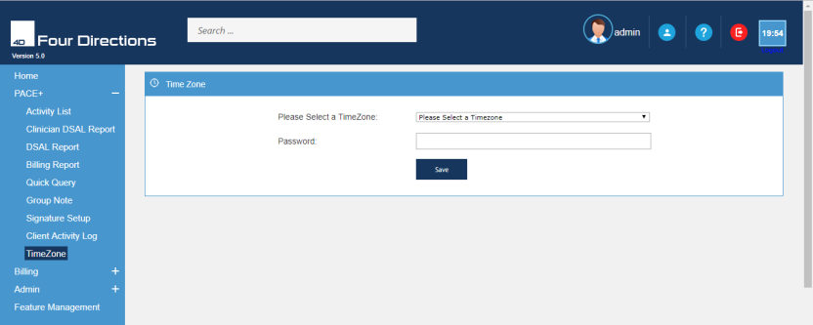
Timezone feature is used to get the application time to the time zone of the client for that we have to go the timezone page in Pace and client the desired timezone give the authentication with the password and save it after that we will be in the timezone

Dash Board
Click on the dashboard. In this section, you can get the data of “compliant & non-compliant”. The red area shows the percentage of Non-complaints and the blue area shows the percentage of complaints like in assessments, service plan etc.
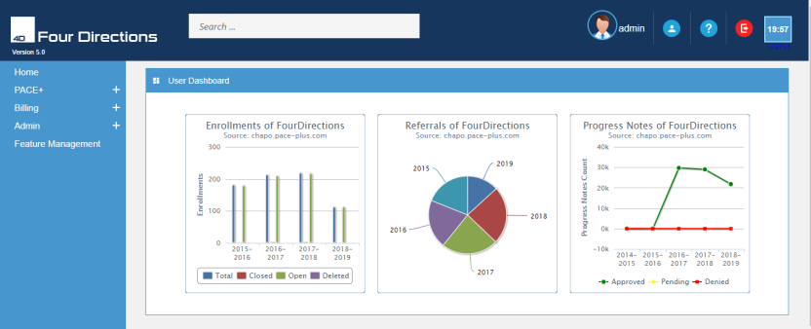

Billing
Billing functions can be found under the “Billing Tab”. Based upon your “role” and permissions, it will be located at the top of your PACE+ user screen. Clicking on the “Billing” menu will open a drop-down of various submenus. Much of the billing background data entry; For Example setting up Providers, Payors, and License Groups must be done before any billing can occur. Depending on the organization this might be done by the Administrators; CFO; Billing Department and/or some other responsible person. Billing menu consists of:
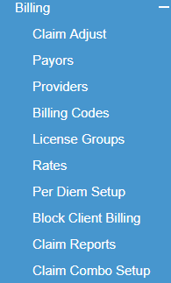
Deciding what utility and function you wish to carry out will determine what submenu item you need to open. Click on the submenu you wish to open.
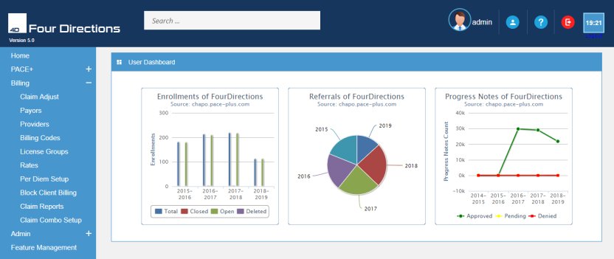

Billing codes
Billing codes are associated with an activity or service that is used for billing reimbursement. When new billing codes are required you can easily create them. If there are any changes in the code numbers, billing units, or non-billable to billable status, you can make the changes easily by editing the existing billing code.
HCPC codes and Current Procedural Terminology Codes (CPT’s) are included in the PACE+ billing system. HCPC are categories of health/medical procedure codes (Level I HCPCS codes are the CPT (CPT-4) professional services codes). PACE+ is designed to track the services performed/permitted and the number of units (time) for billing purposes and/or time tracking for a service program.
Click on the “Billing Codes” sub-menu tab under the menu tab of Billing from the main page.
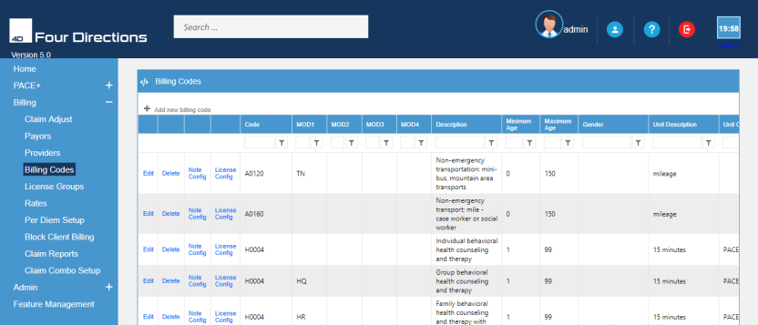
Click on the billing codes- takes you on the editor page. It consists of different types of functional key like Edit, Delete, note config, License config, insert, cancel, codes, MOD 1, MOD2, MOD3, MOD4, Description, minimum age, maximum age, Gender, unit description, unit calculation, variable rates, maximum groups, show time, require time, minute per unit, default unit etc.
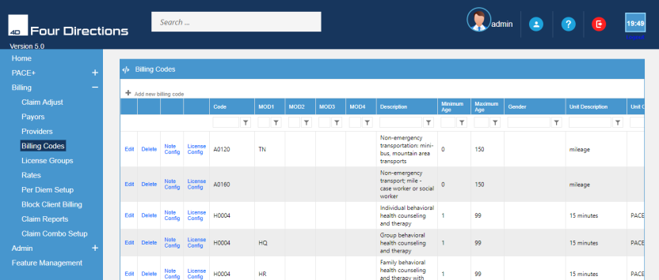

Adding New Billing Codes
Click on the “Add New Billing Code” at the top left side of the page. This will open the “Add new billing code” screen for you to add the new information. Enter data in the form that is required. Click the “Insert” command after you have entered the new data. This will make the Billing Codes available for billing purposes.
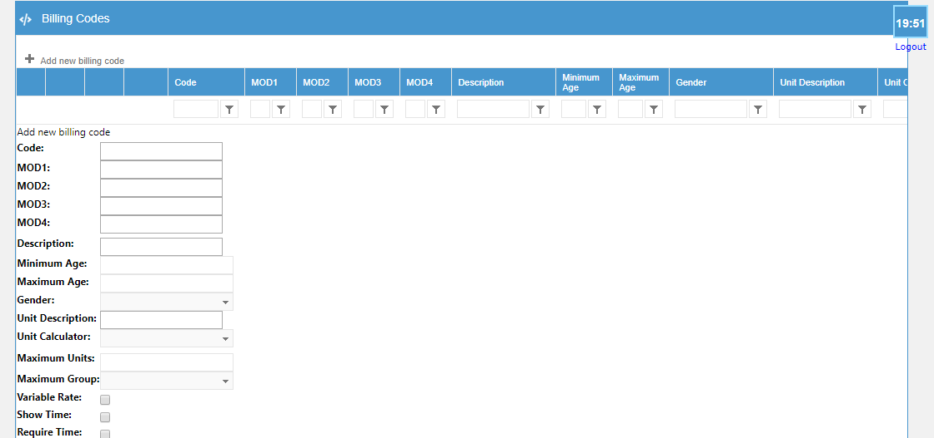

Edit Billing Codes
Once you have opened the Billing Code screen, search for the billing code that you want by using the filter boxes (see red highlighted). Click on the “Edit” command in front of the existing billing code. This will open the “Edit Billing Code” screen and you will be able to make any changes that you need. After changes have been made, click the “Update” command at the bottom.
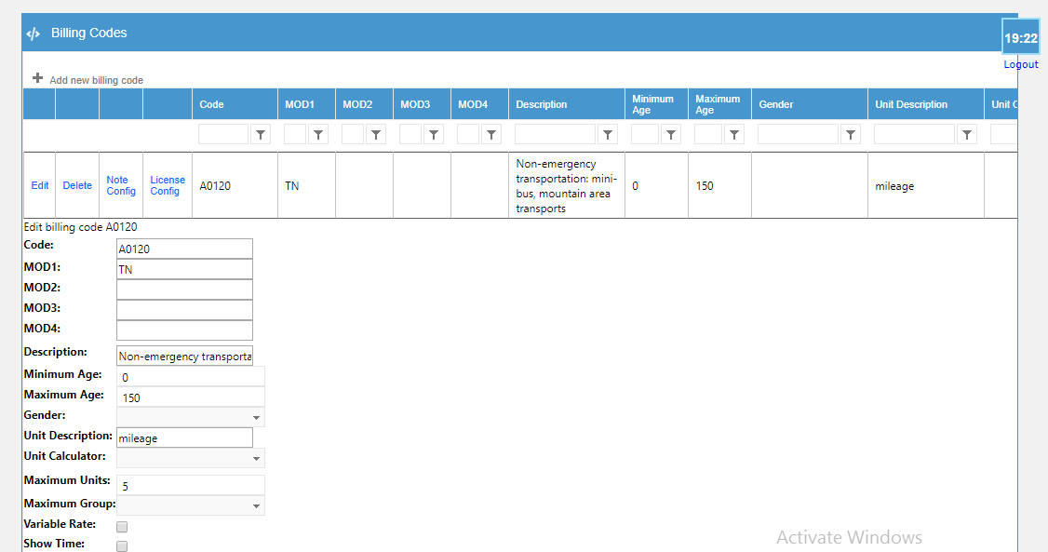

Delete billing codes
Select the billing code that you wish to delete. But deleting a Billing Code is something that usually is not done. But if a code is entered incorrectly, data entry mistakes are possible and you need to delete such a mistake – you can do so. When you click on it, this will bring you a screen asking Are you sure you want to delete this Billing Code? If you click on ok, it will be deleted.

Note config
This function quickly adds or removes this billing code’s availability on whatever specific types of notes your organization uses. Some of the more common types are Progress Notes; Psych Progress Notes; Psych Evaluations, Crisis Progress Notes, and Personal Assistance Progress Notes. For agencies that have multiple types of notes and want to restrict the codes available on certain types of notes, this function should be used.
- Click on the “Add o Note” tab. A note will be open with a command of remove from notes.
- Click on the “Remove from Note” to unlink this billing code from this type of note.
- A “Yes” in the Available Code column means you must set-up the Note Configuration for all billing codes.
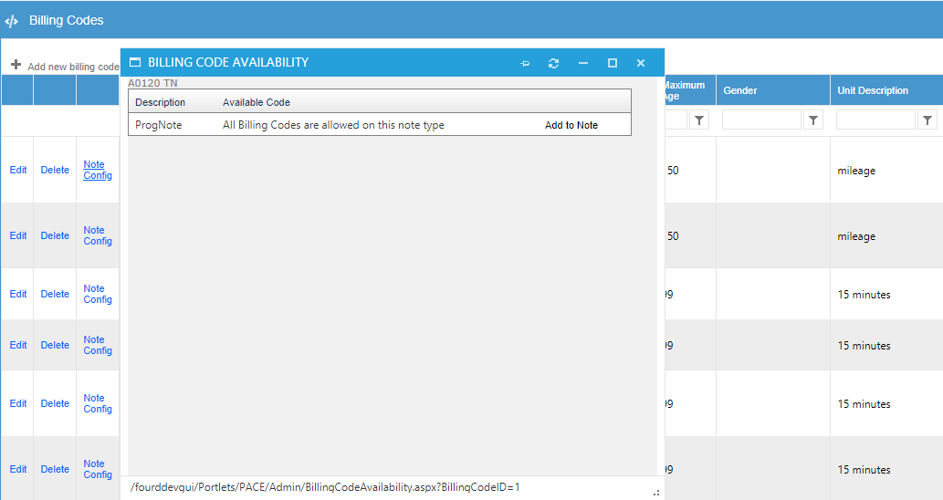
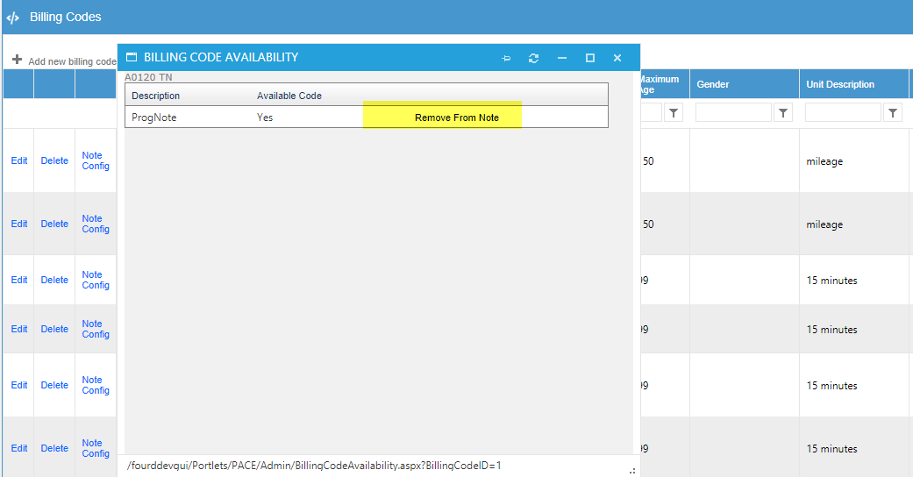

License config
Click on the “License Config” command at the left of that billing code. A new screen will come. Select the License Group you wish to block from using this billing code from the “License Group Blocked” dropdown list and select the License Group you wish to give permission to use this billing code by selecting them from the “Replacement License Group”. In the end, Select the “license group to block from sending NPI” from the drop-down list. After that, click on the save which is in blue colour. The use of this function is specific to whichever Billing Code you are using it on.
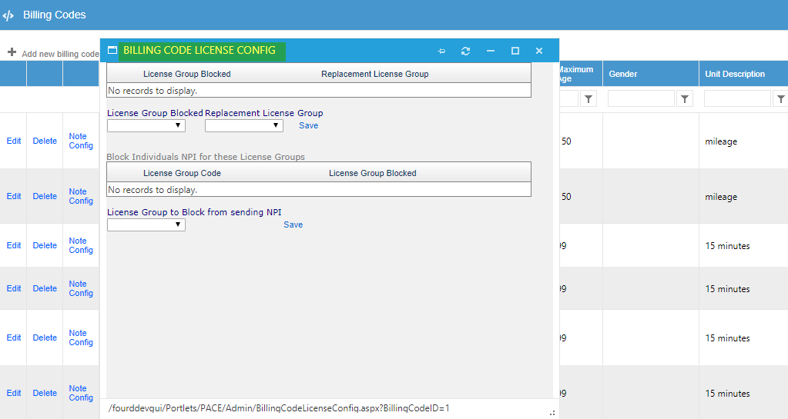

Claim adjust
Go to the billing menu, a drop-down list will come. Click on the “Claim Adjust”. A new screen will come. An adjustment is submitted to correct one or more fields of a previously paid claim. Any field, except the Provider ID number or the Patient’s Medicaid ID number, can be adjusted. Individual claims and encounters can be quickly reviewed for claim processing and research purposes by the Claim Department.
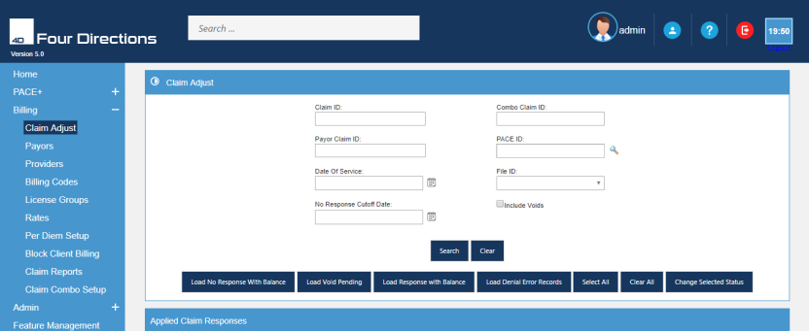
Click on the claim adjust-takes you on the edit page. Here you can search Client ID, Payor Claim Id, date of devices, Pace ID, File ID, Search, Clear, select all, Clear all, change selected status, ID, units, amount balance, status, combo claim Id, Payor etc.
You can find the reports through Claim ID, Combo claim ID, Payor Claim ID, Pace ID, Date of service, File ID. When you click on the search icon of Pace ID, a new screen will come. Write down the first name, Last name, date of birth, SSN and click on search. For Example, if you put the First name like Bob, a list will come then “select” the name.
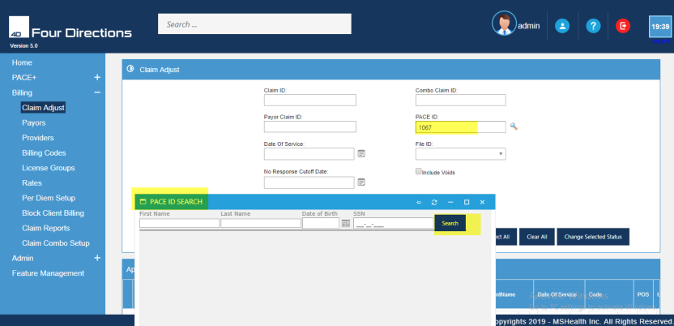
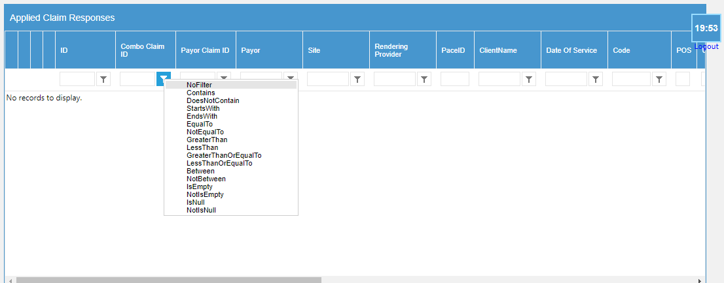
Click on the file ID, a new screen will which is consist of Edit icon in front of each billing entry. Selecting the icon will open the screen below and allow edits to the data. Then you select the update or the cancel choice, search icon will open this screen and allows for you to view the “encounter” / progress note. You can edit the note by clicking on the progress note that will open for you to view or make billing code/ unit etc. “Ledger” icon will open this screen and allows for you to view the Ledger Entries Notice the icons in front of each billing entry.

Billing Flow
For billing flow, the user must create the coverage otherwise it’s not possible to proceed with billing flow. Click on the ‘Pace+’ tab from the main menu. The below-shown screen appears.
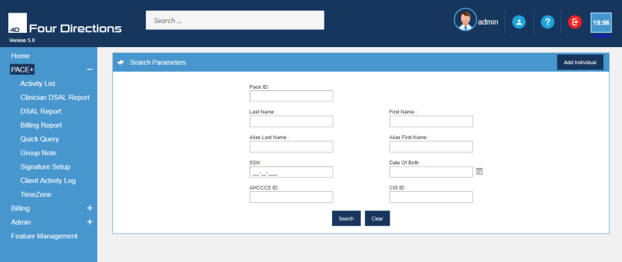
When you click on the pace+, you will come to this page. Here you will initiate the “Client Search” or to “Add Individual”.
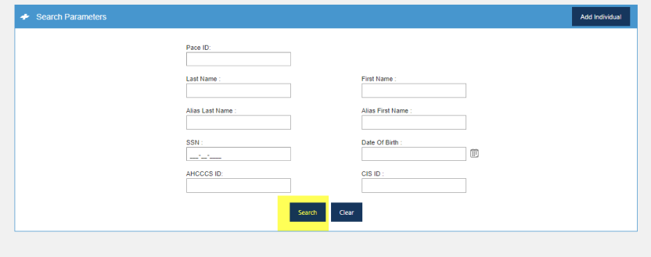
As the search result appear. Select any of the PaceID. A new window appears.
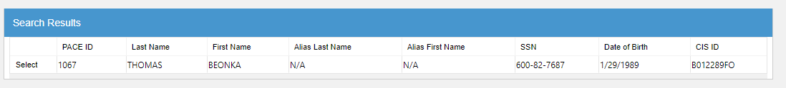
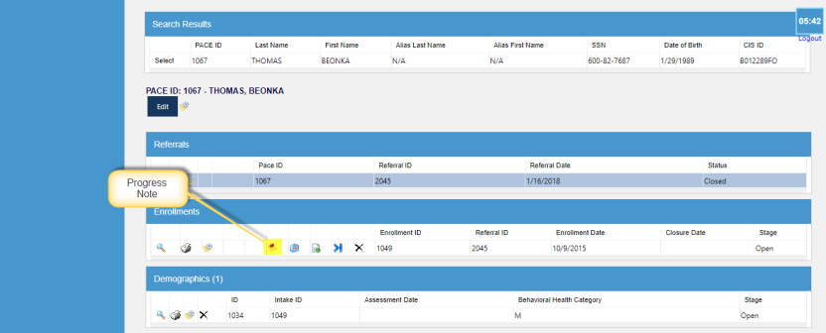
Add progress note. Go back to the enrollment grid and select the “progress note”. A form will occur which consist of the followings:
- Date of service (DOS)
- Time In, Time Out
- Site
- Clinician
- Billing Codes
- Narrative
- Signature
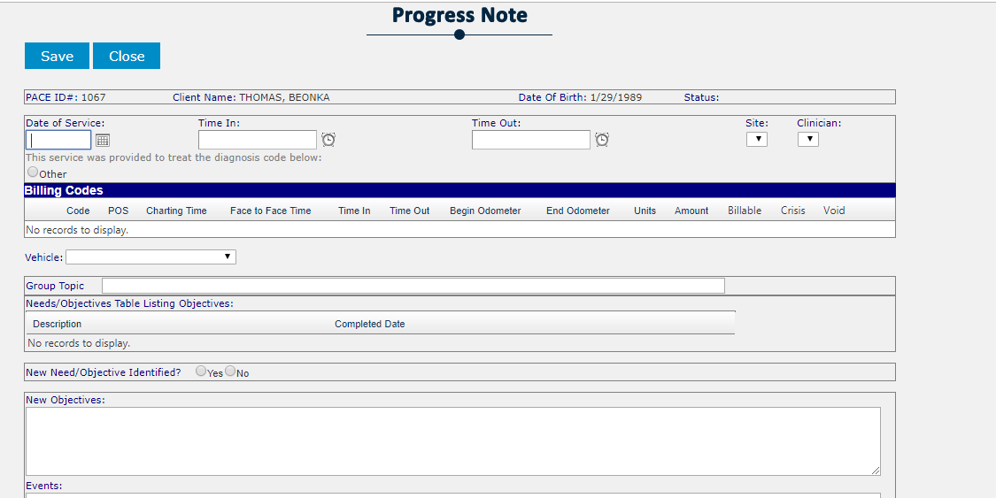
Click on Save Button. The progress note is added. The Progress Note form is saved in the Progress Notes grid. Progress Notes grid consists of these fields Progress Note ID, Enrollment ID, Date of Service, Clinicians, Location and Signed.
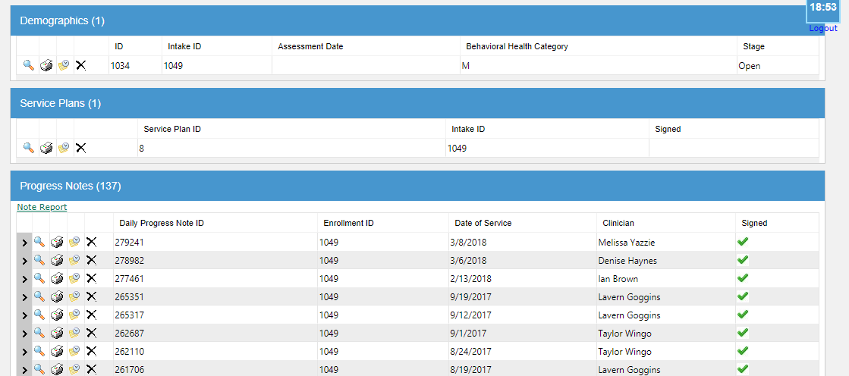
Click on the activity list. This will open the “activity list” screen as shown below. Enter the ID (Progress Note ID). Select the workflow type from the dropdown. The WorkFlow Type must be ‘PACEWF.NoteApproval’ and click on the Search button.
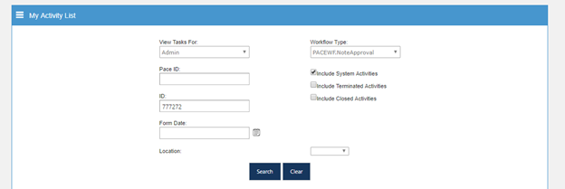
Now you can see the following details (Pace ID, ID, Workflow Name, Activity ID, Name, Details, Current Location, Location output). The current status shown is pending. Click on Location output to change the currents location status as Approved. Click on submit button to successfully approved the file.
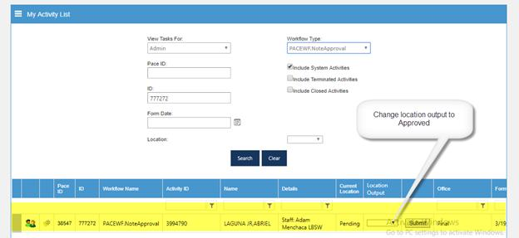
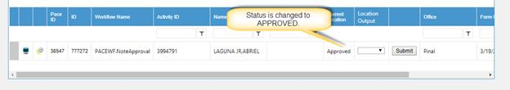
Go to the Billing tab. Click on Add Encounter.
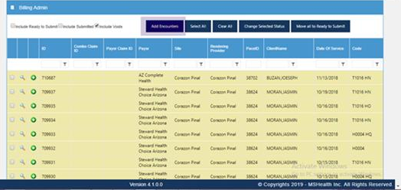
Start filling the details. Select provider and payor(payor should be the same as you select during coverage adding). Select the end date. We will add encounter of that pace id after checking the payor and provider progress note criteria. Click on Check for Exceptions.
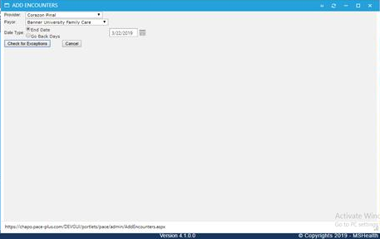
Now create an Encounter by click on Create Encounter button.
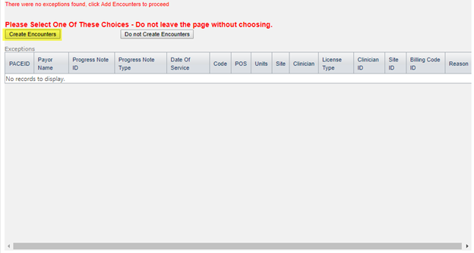
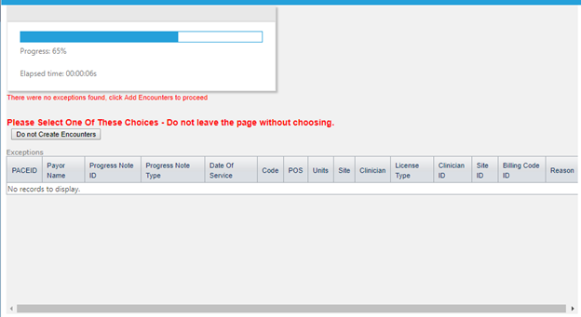
As the Encounter is created successfully it is shown in the Billing window as shown below. Search your ID by entering DOS.
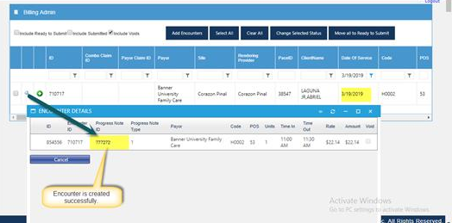
Click on Check for inspections. Note ID is showing in claim adjust and successfully submitted.
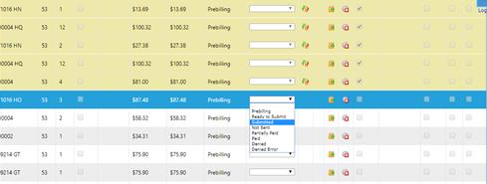
After Submission. Go to the Claim adjust from the menu. Enter the Pace ID, hit the search button so that all billing details are shown.
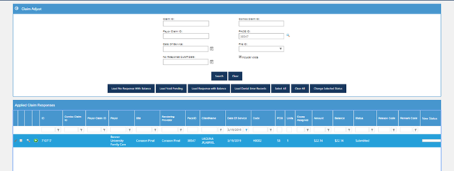
Go to the File outgoing under the Admin from the main menu. We will generate the file for all the encounters listed under the criteria of the payor and provider e.g (Pinal, Arizona) etc
It will create a file in the green then we need to send it to the cleaning house by clicking and sending it automatically to the SFTP or we can manually send it by downloading it and uploading it to the site of the cleaning house which they are using.
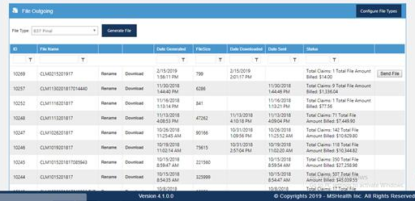

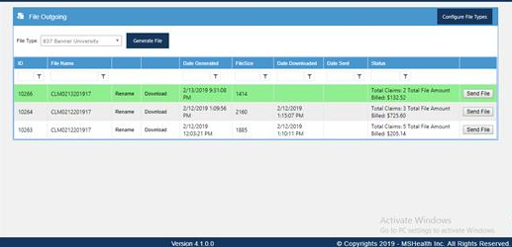After the file outgoing process complete. The file will be processed by the cleaning house, and the file return by them will be uploaded to the file incoming of the system either by uploading it manually or you can click “Get Files From FTP” button.
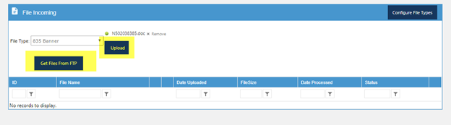

Payors
Hovering over the billing section on the functional page, a drop-down list will come. Click on the “Payors” submenu to open the Payors screen. A Payors are any source that you submit billing to or receive payment from for services.
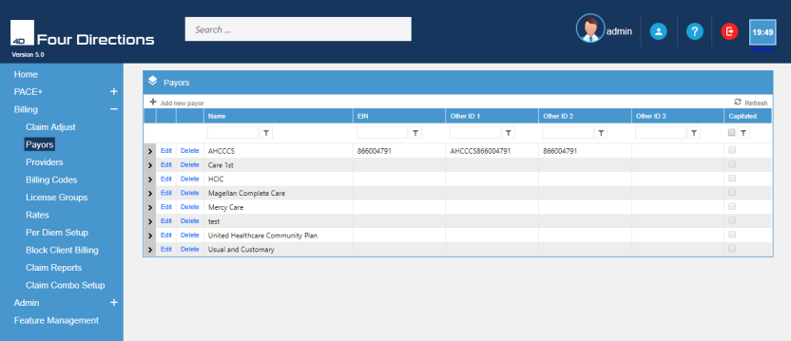

Add New Payor
Click on the payor – takes you on the edit page. Locate the “Add new payor” command at the top left side of the page. This will open the “Add new payor” screen for you to add the new payors information. Enter information in the form that is required of you.
After filling the form, click on the “insert”. This will make the Provider available for billing purposes.

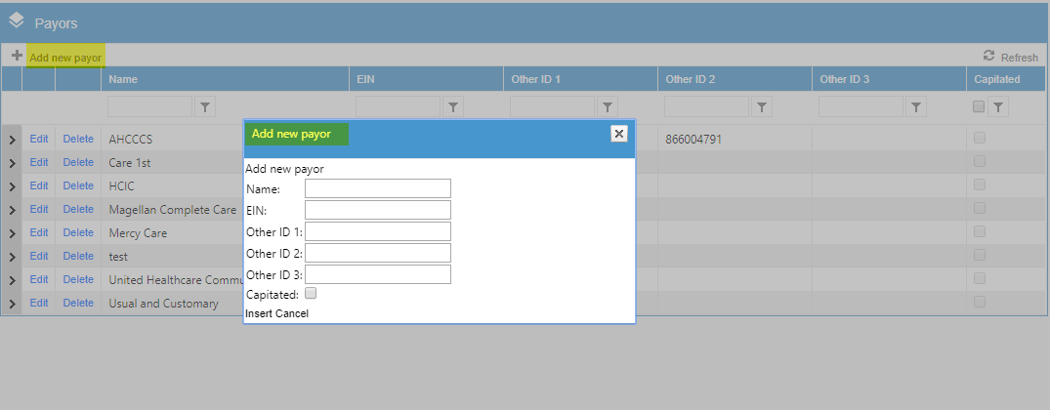

To Edit Payor
To edit payor, locate the Payor on the Payor Screen, use the filter for the user; username. Click the “Edit” command in front of the Provider to open Provider screen. Make the changes or edits required. Click “Update” to save edits.
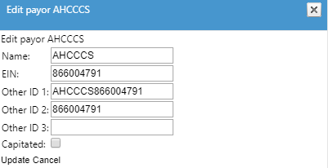

Delete the Payor
Select the payor that you wish to delete. But deleting a payor is something that usually is not done. But if a code is entered incorrectly, data entry mistakes are possible and you need to delete such a mistake – you can do so. When you click on it, this will bring you a screen asking Are you sure you want to delete this Billing Code? If you click on ok, it will be deleted.
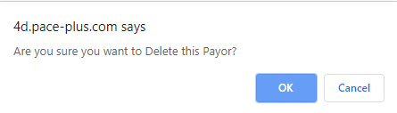

Providers
Hovering over the menu of billing, sub menus list will open. Click on the “provider”. It records name, business name, addresses, phone numbers, provider type (office, doctor, individual, house etc.), ID numbers (federal, state and local), and activation/deactivation of the provider. It also contains the license records, as well as contractual information.
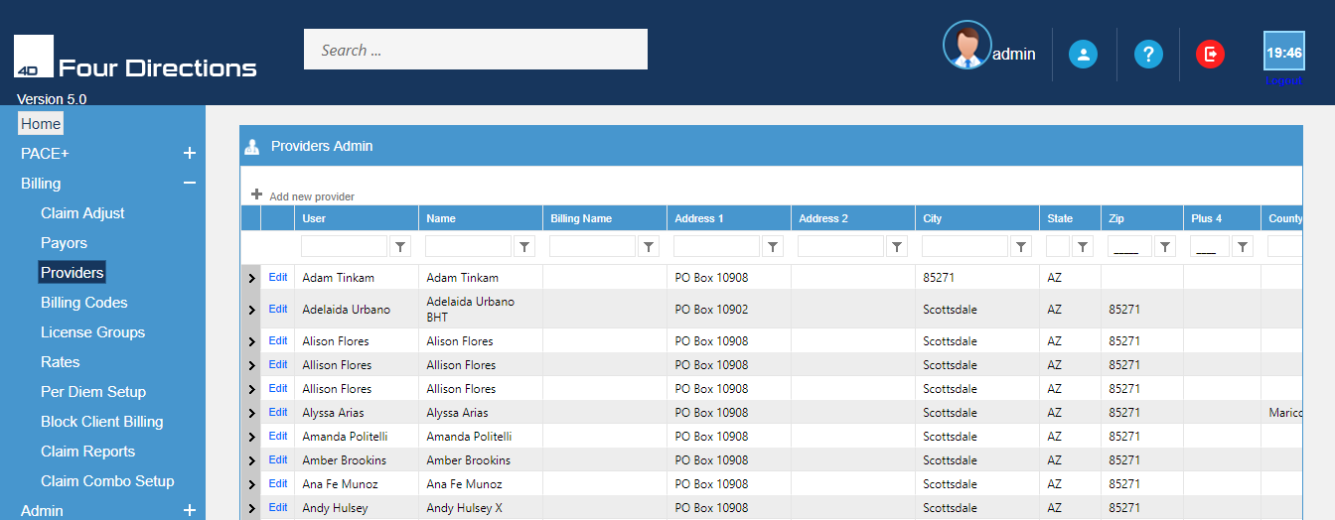

Add New Provider
When you click on the provide-takes you on the editor page where you can Add, edit, delete the forms etc. Hit the “Add new provider” command at the top left side of the page. This will open the “Add new provider” screen for you to add the new Providers information. After you have entered the new data, click the “Insert” command. This will make the Provider available for billing purposes.
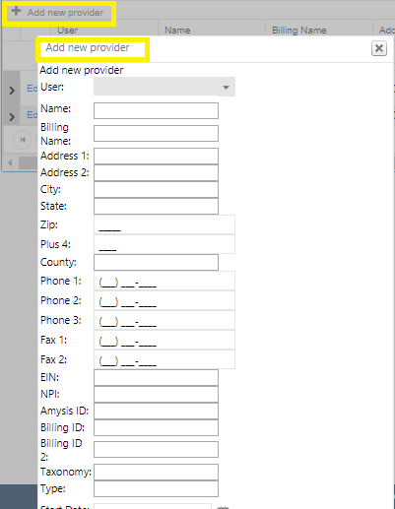

To Edit a Provider
Hit the Provider on the Provider Screen; (either scroll or use the filter for the user; username or Billing Name) Click the “Edit” command in front of the Provider to open Provider screen. Make the changes or edits required after that Click “Update” to save edits.

License group
Select the menu tab of billing, the sub-menus list will open. Click “license groups”.
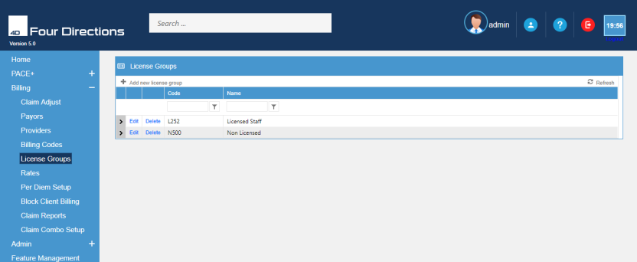

Add New License
Click Add new license- takes you on the editor page. Add new license information. Save by clicking “Insert” command at the bottom. It requires codes and name.

To Edit the License
Hit the license group on the license group Screen; (either scroll or use the filter for the user; username or Billing Name) Click the “Edit” command in front of the groups to open license group screen. Make the changes or edits required after that Click “Update” to save edits.
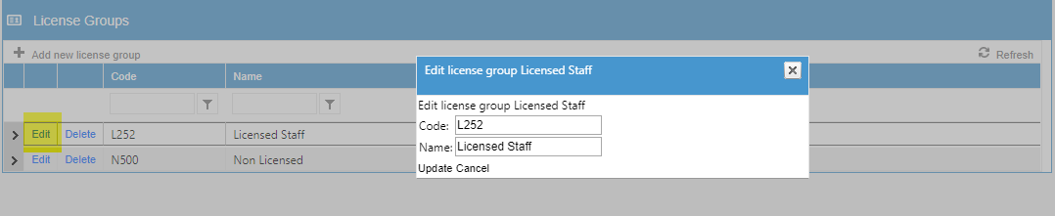

To Delete
Select the license group that you wish to delete. But deleting a licensed group is something that usually is not done. But if a code is entered incorrectly, data entry mistakes are possible and you need to delete such a mistake – you can do so. When you click on it, this will bring you a screen asking Are you sure you want to delete this Billing Code? If you click on ok, it will be deleted.
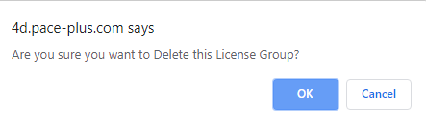

Rates
Hovering over the menu of billing, a sub-menus list will come. Click on the “Rates”. (Billing) rates are the amount established to charge for specific services/products. The amount of reimbursement that the payor will pay for services. The billing rate may vary by types of customers and/or services/products, or types of providers.
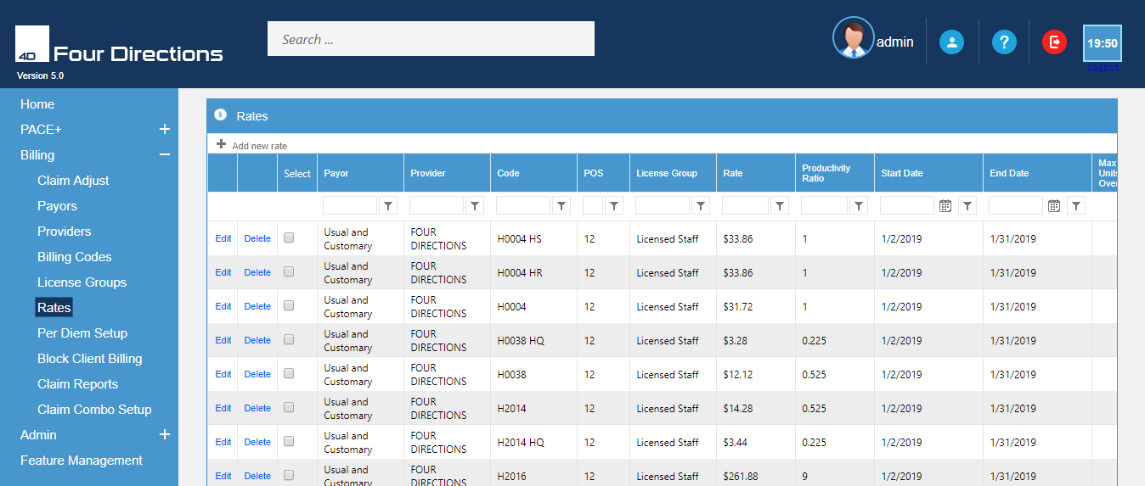

Add New Rate
Click the “Add new rate” command at the top left side of the page. This will open the “Add new rate” screen for you to add the new information. Enter the required information and Hit the “Add” button.
Hit the “Copy rate” Command bar that allows all displayed rates for the designated code to be copied and inserted.

To Edit the Rate
Hit the Rate on the rate Screen; (either scroll or use the filter for the user. Click the “Edit” command in front of the rates group to open rate screen. Make the changes or edits required after that Click “Update” to save edits.
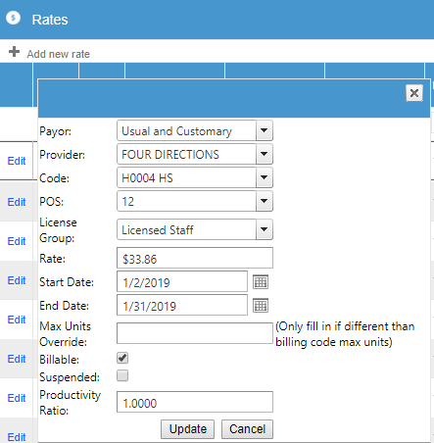
Per diem setup
Hovering over the billing section, sub-menus list open. Click on the “Per Diem Setup”. In per diem reimbursement, an institution or agency receives a set rate per day rather than reimbursement for charges for each service provided. Typically refers to charge or payment methods based on a set rate per day of care. Per Diem reimbursement can vary by service types or can be a set rate.
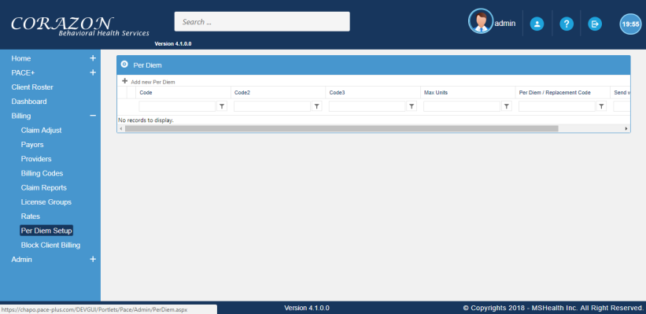

Add New Per Diem
Click on the “Per Diem Setup” submenu to open this screen. This will allow you to “Add a new Per Diem”; edit or delete an existing Per Diem code. On the left-hand side at the top, click on the “Add New Per Diem”. A form will come on the screen which is consist of code, code2(only add if 2nd code rolled up), code3, Max Unit, Per Diem code, switches at max. After filling the form hit the “Add” button.
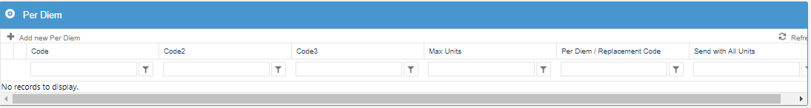

About Admin Menu
Once you are logged in as an administrator you will want to look for the Admin menu button. It is locating at the top of the page beside the other buttons. Hover over the Admin menu. You can see the drop-down list. Drop down list is the following:
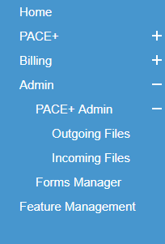
Only those with Admin permission will see this tab. In the Admin block, we are discussing the Admin profile, user admin, and Admin Role.
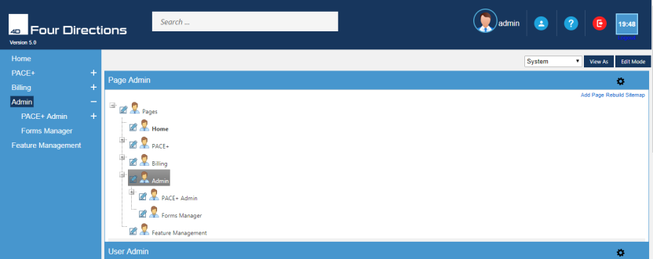
Click on the admin menu-takes you on page Admin. Here you can add the pages to other pages. Click on “Add page” at the extreme top right side of the page. On the left side of the page, menus and submenus pages are given. While click o the “+” sign, open a list of menus that we have discussed above. All the forms are created here. This is basically the “ Admin Page”. These functionalities are controlled by Admin. Who has the authority to develop, maintain, add users, create their roles etc? Only those functionalities will be shown to the user which are permitted by the admin.

When you click on the “Add Page”. A new screen will come that is Edit page. Here you can write the title, Description, URL and select the target from the drop-down list. After completing the form hit the “Save” button. You will successfully create the page.
Scrolling down the page- takes you on the “User admin” page. Click on the “Add User” command at the extreme right side of the page. This will open the new screen that is “Edit User” for you to add the information. Here you must tick the “Enable Login”. In this way, the user has access to log in the app and work on the menus that are assigned to the user. After completing the form, click on the “Save” button. Once the administrator has entered a temporary password, then the user may change it at their pace+ screen.
Scrolling down- takes you on the “Role Admin”. Here you can add the new records while clicking on the “ Add New Record” at the top left side of the screen. Write down the role name, description and click on the “Save” button. You can filter the Roll ID, Rolename, Description by clicking the icon . You can Edit, Role, add new members or check their names, Delete them in this tab.

PACE+ Admin
Hover over the menu Admin, a drop-down list will come then click on the PACE+ Admin submenu to open a data tree.
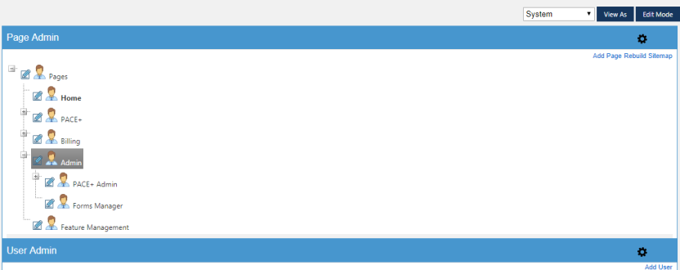
Click on the + in front of “Lookup Values” to open the branches of the menu tree. What is now displayed are all the drop downs for all the forms. They have been labelled for easy identification. Find the drop-down that you need to revise or change.
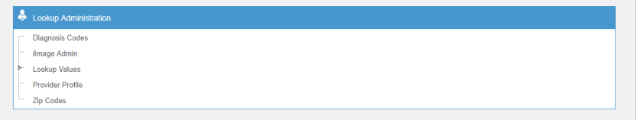

Diagnosis Code
Click on the “ Diagnosis code” a new screen will come on the page. You can see different types of codes. These are those codes which are found in almost every form like Demographic, psychographic etc. You can delete or edit the existing and/or search the codes according to your requirement. You can also add new codes while clicking on the “Add New Codes”.

Image Admin
After the diagnosis codes, move towards “Image Admin”. After click on it, a new screen will come on the page. It is based on “Setup subfolders and/or Doctype”.
- Click on the “Add Subfolders”. Write down the name of subfolder you want to add in the drop-down list and click on Active.
- Hit the “Save” button.
- You can “Edit” the subfolder name.
- Click on the “Doctype”. A new screen will come on the page. Select the Doctype from the drop-down list and hit the “Add” command.
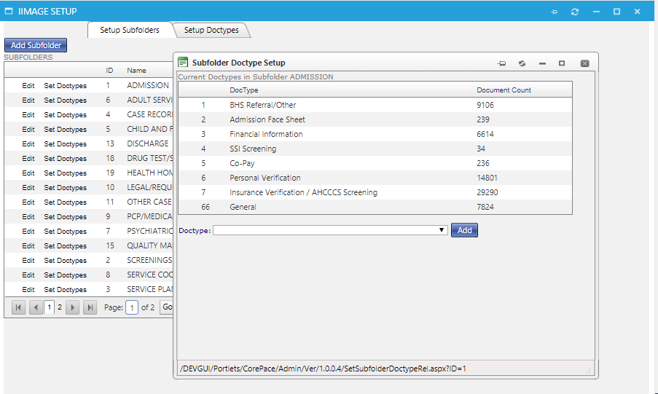

Move towards “Setup Doctype”. After click on it, a new screen will come on the page. Click on the “Add Doctype”. Write down the name of doctype and click on “Active”.
- Hit the “Next” button.
- You can check your Doctype Active status whether it is true or not.
When you click on the “Next”. A new screen will come on the front page. Here you can check the field name and field type. You can add the “field name” and “Add type” to the drop-down list. After that hit the “ Save” command.

Lookup Values
Click on the icon in front of the lookup values. What is now displayed are all the drop downs for all the forms. They have been labelled for easy identification. Find the drop-down that you need to revise or change.
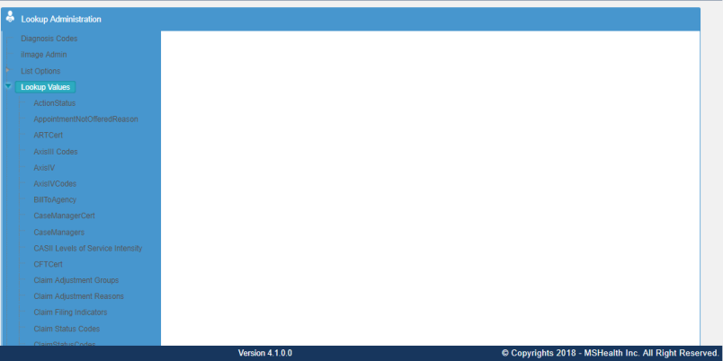
For example, click on the AxisIV, a new screen will come on the front page. Here you can edit the existing records and also “Add New Records”.
- Click on the Add New Records
- You must enter the codes it might be an abbreviation, letters, symbols etc, description.
- You can make Active on all forms
- Write the Effective date for this it can be available for use
- Enter the short name, type, and flag.
- Once all the information has been saved, click the “Save” command bar, and the selection will now be available.
Once an entry is created, it can not be deleted. But you can inactive them only or make changes in it. It will appear in the table alphabetically.
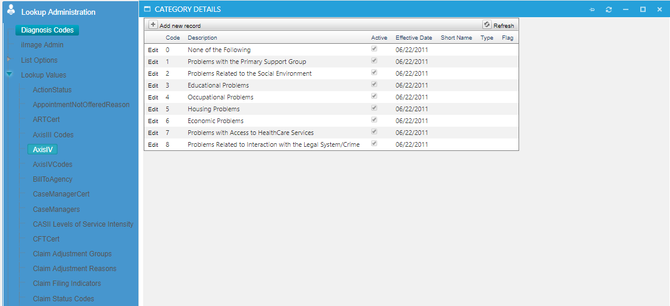
To edit a record entry, click “Edit” and this will bring up the edit screen where you can revise and change the entry. It is in “Edit” that you will check or uncheck the “Active” arrows. The “Active” checkbox makes the entry available or removes it from displaying on command.

File Out Going
PACE+ has developed a feature to assist in creating files to be downloaded to the user’s machine or sent directly to the FTP server. FTP is basically File Transfer Protocol (FTP). It is the standard network protocol used to transfer files from one host to another host over a TCP-based network, such as the internet. If your agency can not send files directly, it allows for these files to be saved on your computer and then sent manually.
Go to the admin menu on the front page. Hover over, a submenu list will come. Select the “File Outgoing” submenu command.
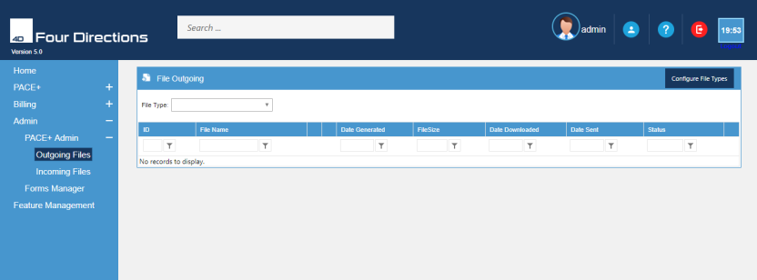
Selecting the files outgoing – takes you on that page which is based on “File type, ID, File Name, Date Generated, File Size, Date Downloaded, Date Sent, and Status. If the file type is available, select the type from the drop-down, you want to send or save. This will display all files of that type.
- The date that the file is downloaded.
- Date Sent Date that the file is sent to FTP Server.
- The “Status” is created when the file is generated. It tells the status based upon the file type.

Select the file type from the drop-down list. Then it’ll generate the files. You can remove or generate the files according to your requirements. To “Rename” a file clicks the “Rename” command after the file’s name. This will open the “Rename File” screen and allow you to rename a current file. Hit the “save” command.

To create a new file type, select “Configure File Types” at the extreme right- hand side, in blue colour Click on it, a new screen will pop up on the current page. Here you can add and Eid the file. You can check the outgoing file checkmarks. Click on the “Add New File Type”.
Click on the “ Add New File Type” pop-up a new screen which is basically a form, consist of different functions. After completing the file, selecting the Transfer Mode from the drop-down list and check the outgoing file( if you select the outgoing file then it’ll appear on the lost, to them for). After that hit “ Insert” command.
You can edit the files. Click on the “Edit”. A new screen will come on the page. You can edit it according to your requirement and hit “update” command.

Files Incoming
This feature allows you to see Processed Files, files that are from another source to your agency. It allows you to read, process and write results to PACE+. By knowing the “Status” of a file, you can then research and make any necessary corrections.
Hover over the menu Admin on the front page, the functional list will open. Click the “Files Incoming” submenu.
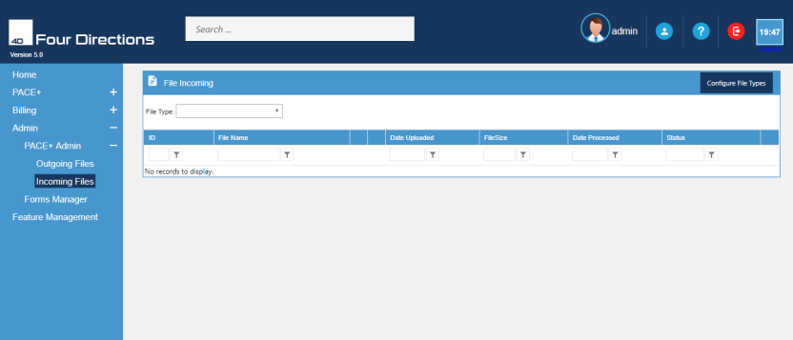
Select “File Type” from the pull-down. Upload the file to PACE+. This can either be done by using the “Get Files from the FTP” button and/or by uploading a saved file from your computer by clicking “Select” and finding it in your C drive. To get files – click “Select” (if files have been saved on your machine. Click “Get Files from FTP” (downloads them directly from the FTP server [AHCCCS]). The “Status” will show how many files have been accepted, and how many files have been denied.
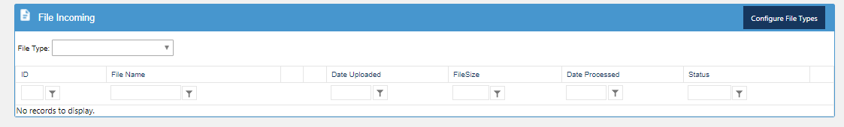
To create a new file type, select “Configure File Types” at the extreme right- hand side, in blue colour Click on it, a new screen will come on the current page. Here you can add an “Edit” the file. You can check the outgoing file checkmarks. Click on the “Add New File Type”.
Click on the “ Add New File Type” pop-up a new screen which is basically a form, consist of different functions. After completing the file, selecting the Transfer Mode from the drop-down list and check the outgoing file( if you select the outgoing file then it’ll appear on the lost, to them for). After that hit “ Insert” command.
Select the file type from the drop-down list. Then it’ll generate the files. You can remove or generate the files according to your requirements. To “Rename” a file clicks the “Rename” command after the file’s name. This will open the “Rename File” screen and allow you to rename a current file. Hit the “save” command. You can also “Download” the files by clicking on the download.
When the green colour bar is present, that indicates that the file has not been processed or is waiting to be processed. For example, we can see on this page, three files were colour. In the end, the file “Process Files” button is given. It means these file is waiting in green to proceed.
